**Seneca High School**

**Air Force Junior ROTC**

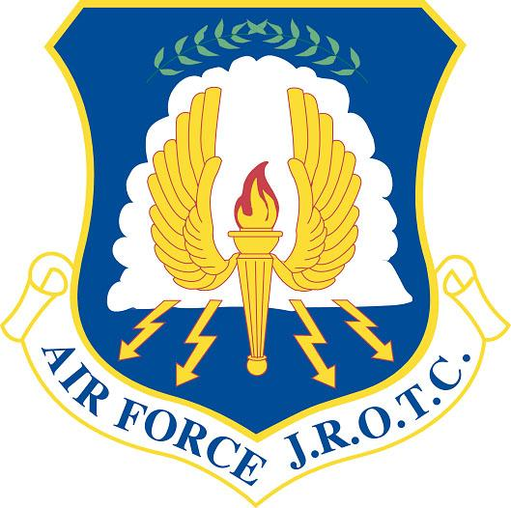

**Cadet Handbook**

**2015 – 2016**

NJ-20101 AIR FORCE JUNIOR ROTC (AFJROTC)

To: AFJROTC Cadets On behalf of the Superintendent, Lenape Regional High School District (LRHSD) and Director, Air Force JROTC Headquarters Air Force Reserve Officer Training Corps (AFROTC), we welcome you to AFJROTC. You will experience a unique course of instruction that will be educating, motivating and rewarding. Many of you will get to do things that others can only imagine. Your experiences in AFJROTC are the foundation for life-long memories and close friendships. We sincerely believe you will benefit from the teamwork, self-discipline and leadership experiences you encounter.

We are sure most students and parents have questions about AFJROTC. **First, let us assure you it is neither boot camp, nor combat training.** It is a class that will help you develop decision-making and communication skills while building self-confidence as a leader. If you have never been in charge or responsible for anything, get ready -- the opportunities are here! While our program will be challenging and demanding, we believe you will experience a sense of accomplishment and pride hard to put into words.

The Cadet Handbook is your guiding light in AFJROTC. All cadets must have a complete and clear understanding of the requirements, standards and policies prescribed for them. While the handbook is directive in nature, the final word on any issue rest with the principal and instructors. We urge your parents to read this handbook in order to gain valuable insight into AFJROTC. This handbook covers information that will answer a lot of their questions.

Again, welcome to AFJROTC. We look forward to working with each of you as members of our team and family. From this day on, you will have the opportunity to improve your interpersonal skills through a challenging leadership education program, and increase your awareness of flight and space operations. We are proud to have you enrolled and stand ready to help you expand your knowledge and horizons. We are delighted to have you on the team!

*Signed Signed*

Senior Aerospace Science Instructor Aerospace Science Instructor

NJ-20101 AFJROTC NJ-20101 AFJROTC

Seneca High School Seneca High School

***“Building tomorrow’s leaders today”***

**AFJROTC MISSION STATEMENT**

***DEVELOP CITIZENS OF CHARACTER DEDICATED TO SERVING THEIR NATION AND COMMUNITY***

**AFJROTC MOTTO**

*BUILDING BETTER CITIZENS FOR AMERICA*

**CADET HONOR CODE:**

*WE WILL NOT LIE, CHEAT OR STEAL, NOR WILL WE TOLERATE ANYONE AMONG US WHOSE DOES*

**OUR CORE VALUES:**

Core values are the foundation upon which a truly quality Air Force Junior ROTC Program is built. Core values are also a fundamental set of guidelines that can serve you throughout your life. These are:

***- INTEGRITY FIRST -***

Integrity means devotion to honesty, truthfulness, doing one’s duty, and doing what is right. This means that your word can always be counted upon and that you can be trusted to accomplish your job.

***- SERVICE BEFORE SELF -***

Service is the giving of self to provide for the welfare of others. Personal desires are not considered in the concept of service.

***- EXCELLENCE IN ALL WE DO -***

Excellence means doing the very best you can in each job you perform regardless of how large, small, difficult, or easy it is to accomplish.

NJ-20101 AFJROTC CADET HANDBOOK July 2015

BY ORDER OF THE SQUADRON OPERATIONS

SENIOR AEROSPACE SCIENCE INSTRUCTOR

This handbook establishes NJ-20101 Air Force Junior Reserve Officer Training Corps (AFJROTC) leadership education/ aerospace science course enrollment standards, curriculum, and academic requirements. It supports the leadership and personal development objectives of AFJROTC by outlining cadet responsibilities, conduct, uniform, personal appearance standards, and the cadet corps organization, operation, and extracurricular activities. This handbook is a supplement to Air Force and HQ AFJROTC directives. All cadets will read this handbook, maintain a copy, know its contents, and comply with its standards to satisfactorily meet AFJROTC course objectives. The Cadet Squadron Commander will review this handbook at least annually and recommend changes to the SASI/ASI.

Title Page Number

Chapter One - Mission, Enrollment, Values, Codes, and Organization 1

Section A - Mission, Goals and Objectives 1

Section B - Enrollment and Disenrollment 1

Section C - Core Values, Code of Conduct, Honor Code, and Code of Ethics 1

Section D – Organization 2

Chapter Two - Classroom Rules/Procedures and Grading Scale 7

Section A - Classroom Conduct 7

Section B - Grading Scale 7

Chapter Three - Customs and Courtesies 8

Section A – Courtesies 8

Chapter Four - Personnel 9

Section A - Cadet Grades 9

Section B - Cadet Officer and NCO Authority and Limitations 9

Section C - Cadet Evaluation Board 10

Section D - Cadet Job Assignments and Cadet Promotions 10

Section E - Awards and Recognition 12

Chapter Five - Uniforms, Equipment, Books, Personal Appearance 14

Section A - Accountability, Cadet Responsibilities and General Policies 14

Section B - Male Uniforms 16

Section C - Male Personal Appearance 17

Section D - Female Uniform 17

Section E - Female Personal Appearance 18

Section F - General Uniform and Personal Appearance 18

Chapter Six - Drill and Ceremonies 20

Chapter Seven - Clubs and Extracurricular Activities 24

Section A - Extracurricular Activities

Chapter Eight - Cadet Health and Wellness Program 25

Section A - Physical Fitness Program

Appendices

A-1 AFJROTC Grade Insignia

A-2 AFJROTC Badges

A-3 Male Cadet Uniforms – Blue Shirt

A-4 Female Cadet Uniforms – Blue shirt

A-5 AFJROTC Lightweight Jacket

A-6 Male Cadet Uniforms – Service Coat

A-7 Female Cadet Uniforms – Service Coat

A-8 Male Cadet Headgear

A-9 Female Cadet Headgear

A-10 AFJROTC Air Battle Dress Uniform

A-11 Tie Knot - Windsor

A-12 Tie Knot - Four-In-Hand

A-13 NJ-20101 Cord & Beret Guide

A-14 AFJROTC Awards

A-15 AFJROTC Ribbon Chart

A-16 JROTC Insignia - Enlisted

A-17 JROTC Insignia - Officer

A-18 US Armed Forces Insignia - Enlisted

A-19 US Armed Forces Insignia - Officer

A-20 Phonetic Alphabet & Military Time

A-21 AFJROTC Uniform Replacement Cost

A-22 Weekly Uniform Inspection Sheet

Back Cover

Chapter 1

MISSION, ENROLLMENT, VALUES, CODES, AND ORGANIZATION

SECTION A - MISSION, GOALS AND OBJECTIVES

1.1 Mission. Develop citizens of character dedicated to serving their nation and community.

1.2 Goals. Our program goals are to instill values of citizenship, service to the community, personal responsibility, and a sense of accomplishment in high school students.

SECTION B - ENROLLMENT AND DISENROLLMENT

1.3. Enrollment Eligibility. To be eligible for enrollment, membership and continuance in the AFJROTC Program, each cadet must be:

1.3.1. Enrolled and attending a regular course of instruction at Seneca High School.

1.3.2. Physically fit to participate in AFJROTC training.

1.4. Continued Enrollment. To continue in AFJROTC, students must have successfully completed the previous Aerospace Science course. The SASI will establish enrollment standards with concurrence of the principal for AFJROTC course/classes dealing with student enrollment limits and quality standards.

1.5. Disenrollment: Being in AFJROTC is a privilege. Students will be disenrolled from the AFJROTC program by the SASI for the following:

1.5.1 Failure to maintain acceptable standards including behavior.

1.5.2 Inaptitude or indifference to training.

1.5.3 Failure to maintain personal appearance (hair and grooming) and uniform standards after being identified by the SASI, ASI, or senior cadets.

1.5.4 Failure to abide with Seneca High School student rules of behavior. A history of suspensions and any expulsions may be reasons for disenrollment.

1.5.5 Failure to comply with classroom rules and procedures, or to maintain self-control (disrupting the class).

1.5.6 Parental request.

SECTION C - CORE VALUES, CODE OF CONDUCT, HONOR CODE, AND CODE OF ETHICS

1.6. Core Values. The Air Force core values are: Integrity First, Service Before Self, and Excellence In All We Do! These core values are the basis for the self-discipline that will allow us to achieve our mission and goals.

1.6.1. Integrity First: Integrity is the willingness to do what is right, even when no one is looking. It is the “moral compass” - our inner voice, the voice of self-control and the basis for trust.

1.6.2. Service Before Self. “Service” refers to our duties, and “before self” tells us that professional duties take precedence over personal desires.

1.6.3. Excellence In All We Do. Excellence doesn’t mean just good enough. It means doing your best.

1.7. Cadet Code of Conduct, Honor Code, and Code of Ethics. These codes are closely related and supplement each other. They belong to the cadets and guide them as they strive to become productive citizens in a society with demanding and often conflicting standards and questionable role models. Cadets should strive to instill these values in themselves and their fellow cadets to the best of their ability at all times.

1.7.1. Cadet Honor Code. “**We will not lie, cheat, or steal nor tolerate anyone among us who does**.” These simple words are the basis for a code to live by the remainder of your life. These are simple but tough rules to live by as reflected by the troubling and alarming number of students who freely admit they cheat in school. A cadet should be HONEST in both words and deeds. A cadet should not make quibbling and evasive statements, should do their own work, and assist others in a sense of cooperation to meet Corps goals. Trustworthiness is not only noble but also necessary for the welfare and continued existence of our civilized society. This code requires hard work for long-term success.

1.7.2. Code of Ethics. Cadets will:

1.7.2.1. Respect your parents, school officials and staff, teachers, and community leaders.

1.7.2.2. Refrain from any act or derogatory word(s) or acts which would discredit your family, school, Corps, or yourself. Vulgar conduct and language is not socially acceptable, hinders communication, and discredits the speaker.

1.7.2.3. Dedicate yourself to succeed in academics, athletics, extracurricular activities, and work.

1.7.2.4. Perform all assigned duties and meet all obligations in a timely manner.

1.7.2.5. Maintain self-respect, self-control, and good behavior.

1.7.2.6. Be honest and understand that honorable failure is better than success through unfair means.

1.7.2.7. Be proud of your uniform and the commitment to AFJROTC that sets you apart from others.

1.7.2.8. Be an exemplary role model with high standards of conduct.

1.7.2.9. Respect other cadets and follow the directions of senior cadet officers.

1.7.2.10. Place the good of the Corps ahead of personal gain.

SECTION D – ORGANIZATION

1.8. Cadet Corps Organization. The NJ-20101 Cadet Corps is organized as a Cadet Squadron as shown in Figure 1.1. The cadet leaders will run the Corp organization to the maximum extent with guidance and supervision of the SASI and ASI. The cadet leaders will hold regular staff meetings to disseminate information, receive progress reports, discuss Cadet Corps activities and present recommendations and suggestions. These meetings will be conducted in a formal atmosphere and led by the Squadron Commander. Attendance for all Cadet Staff Officers is mandatory unless prior arrangements for excuse have been made with the SASI/ASI.

1.9. Job Descriptions. Job descriptions for cadet corps staff positions are contained in Figure 1.2. Like the Air Force, job responsibilities and duties increase with each promotion. Cadets earn their job assignments and are entrusted to carry out their job duties, to include supervisory responsibilities, to the best of their ability.

1.10. Unit Manning Document. The Unit Manning Document (Fig 1.3) is a document that shows the number of positions authorized within the Cadet Corps and the highest rank authorized for the each position. Cadets assigned to the various staff positions initially will not normally be awarded the highest authorized rank to allow for promotion based upon superior performance in their assigned duties.

1.11. Chain of Command. Each cadet will know the chain of command and the names of the people assigned to the positions contained in Figure 1.4. The Chain of Command defines lines of authority and communication. Cadets should use the chain for cadet business such as questions on uniforms, customs and courtesies, drill, cadet evaluations and promotions, cadet awards, extracurricular activities, and class rules and procedures.

1.12. Staff Meetings. The cadet Squadron Commander will hold regular staff meetings to determine the status of on-going projects and activities. These meetings will be the key for the commander and staff officers to establish their goals and priorities for the cadet corps. This is where they will have the greatest opportunity to learn and practice their leadership skills. All senior staff officers and/or their NCOs will be required to attend. If the staff officer cannot attend, it is his/her responsibility to have their NCO attend or coordinate with the Squadron Commander prior to the meeting. Failure to attend may result in removal from a leadership position.

**Figure 1.1. Cadet Organization Chart**

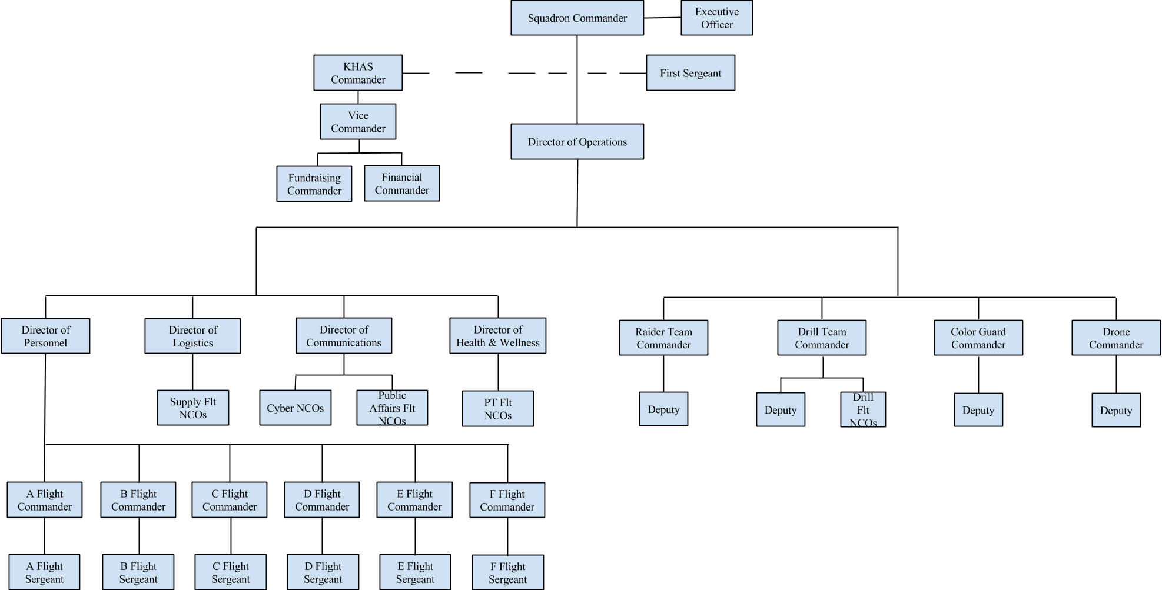

**Figure 1.2 Job Descriptions.**

Cadet Squadron Commander (c/Sq/CC) will:

(1) Serve as the Program’s Cadet Commander

(1) Develop a cadet operations and activities calendar

(2) Advise the SASI/ASI on corps operations policies and procedures

(3) Manage the cadet corps senior staff and conduct regular staff meetings

(4) Ensure all cadets have opportunities to develop their leadership qualities

(5) Chair Cadet Evaluation Board

(6) Establish and enforce appearance, discipline, training, and conduct standards

(7) Performs duties as assigned by SASI and/or ASI

Cadet Executive Officer will:

(1) Inform/assist the Commander as requested

(2) Takes on other projects assigned by the SASI/ASI

Cadet First Sergeant (c/CCF) will:

(1) Serve as the highest enlisted cadet

(2) Helps supervise and improve the morale of the enlisted cadets

(3) Represents the enlisted members of the Corps at staff meetings

(4) Enforce Discipline and AFJROTC Standards

(5) Maintain program policies

(6) Advises the Squadron Commander on matter affecting the enlisted corps

(7) Takes on other projects as assigned by the SASI/ASI

Kitty Hawk Air Society Commander will:

(1) It shall be the duty of the commander to preside at all meetings of the

organization

(2) Be an ex officio member of all committees

(3) Be a special assistant to the corps commander

(4) Ensure that the activities of KHAS do not conflict with those of the corps

Cadet Director of Operations (c/DO) will:

1. Assume command in the absence of the Corps Commander

(2) Supervises staff officers and NCOs

(3) Coordinate c/Sq/CC’s cadet operations and activities calendar

(4) Organizes and supervises extracurricular and co-curricular activities

(5) Advises the c/Sq/CC on Operations activities

(6) Assists c/Sq/CC in selecting project officers for activities

(7) Develop and manage a cadet evaluation and promotion system w/ c/DP

(8) Coordinate with Director of Communications for computer program support

(9) Serve as the recruiting officer for the program

(9) Recommend cadets for jobs, awards, and promotions

(10) Takes on other projects as assigned by the SASI/ASI

Cadet Director of Personnel (c/DP) will:

(1) Supervises the Flight Commanders and Sergeants

(2) Advises the c/Sq/CC on each Flights conduct

(3) Track cadet activities (ie. community service, activities, etc…) on Google Drive

(4) Maintain WINGS for the program

(5) Develop and manage Cadet Quarterly Award program

(6) Manage the cadet awards and decorations program

(7) Track each cadets’ ribbons, ranks, badges, and braids on the Google Drive

(8) Recommend cadets for jobs, awards, and promotions

(9) Takes on other projects as assigned by the SASI/ASI

Cadet Director of Logistics (c/DL) will:

(1) Supervises the Logistics NCOs

(2) Advises the c/Sq/CC on Corps Logistics

(3) Organizes and supervises cadet equipment

(4) Keep track of all Program inventory with spreadsheet on Google Drive

(5) Manage the issue and accountability of uniforms

(6) Assures all cadets have proper uniform items

(7) Train NCOs in all Duties

(8) Recommend cadets for jobs, awards, and promotions

(9) Takes on other projects as assigned by the SASI/ASI

Cadet Director of Communications (c/DC) will:

(1) Supervises the Communications NCOs

(2) Advises the c/Sq/CC on Corps Computer Systems, Announcements and Imagery

(3) Organizes and supervises computer system programs

(4) Maintain Program Google Drive

(5) Maintain Program Website

(6) Maintain Cadet Social Media (Twitter, Facebook, YouTube, etc...)

(7) Maintain Program display case

(8) Create and publish Program Newsletter each quarter

(9) Coordinate and maintain connections with school newspaper

(10) Train NCOs in all Duties

(11) Recommend cadets for jobs, awards, and promotions

(12) Takes on other projects as assigned by the SASI/ASI

Cadet Director of Health & Wellness (c/DHW) will:

(1) Assist SASI/ASI in conducting the Cadet Health & Wellness program

(2) Advises the c/Sq/CC on Corps Health & Wellness activities

(3) Establish and lead bi-weekly exercise plan

(4) Create and publish bi-weekly PT Op-orders

(5) Record cadet performances to determine eligibility for H&W ribbon or certificates

(6) Coordinate with Director of Personnel for input format and requirements

(7) Train NCOs in all duties

(8) Recommend cadets for jobs, awards, and promotions

(9) Takes on other projects as assigned by the SASI/ASI

Raider Team Commander will:

(1) Establish rules, objectives, procedures and routines for practices

(2) Keep records for attendance at practices and performances

(3) Coordinate with c/DL for uniforms

(4) Train Raider Team members for all routines

(4) Train Deputy in all duties

(5) Coordinates with SASI/ASI for competition participation

Drill Team Commander will:

(1) Establish rules, objectives, procedures and routines for performances

(2) Create and publish bi-weekly Drill Op-orders

(2) Keep records for attendance at practices and performances

(3) Train Drill Team members for all routines

(4) Train Deputy in all duties

(5) Coordinates with SASI/ASI for competition participation

Color Guard Commander will:

(1) Establish rules, objectives, procedures and routines for performances

(2) Keep records for attendance at practices and performances

(3) Train Color Guard members for all routines

(4) Train Deputy in all duties

(5) Coordinates with SASI/ASI for competition participation

Drone Club Commander will:

(1) Establish rules, objectives, procedures and routines for practices

(2) Keep records for attendance at practices

(3) Train Drone Club members for all routines

(4) Train Deputy in all duties

(5) Coordinates with SASI/AS

Cadet Flight Commander (c/Flt/CC) will:

(1) Command flight in classroom and in formal formations

(2) Report in to Instructors with attendance after the bell

(3) Enforces discipline, dress and appearance standards

(4) Ensure compliance with classroom rules and procedures

(5) Instill teamwork/esprit-de-corps within the flight.

(6) Supervise cadets and write evaluations on performance, conduct, leadership/promotion potential.

(7) Inspect flight members during uniform and personal appearance inspections, as directed

(8) Advise c/DP of any flight concern/problem affecting the Corps

(9) Submit request to c/DP for items (i.e. ribbons, rank insignia etc…)

(10) Maintain cleanliness of classroom area

(11) Train Flight Sergeant to assume duties in their absence

Cadet Flight Sergeant (c/Flt/Sgt) will:

(1) Assume command of the flight in the absence of the flight commander

(2) Call room to attention for attendance after the bell

(3) Assist flight commander with flight conduct and discipline

(4) Assist flight commander in teaching drill and ceremonies

(5) Prepare flight for inspection and accomplishing inspection records

(6) Maintain cleanliness of classroom area

Cadet Supply NCO will:

(1) Assist ASI with equipment and uniform inventory, issue and turn-in

(2) Annotate and maintain cadet supply records

(3) Monitor the Supply/Storage room for cleanliness and security

(4) Maintain supply records for inventory/requisition control

(5) Perform and record monthly equipment inventory

Cadet Cyber NCO will:

(1) Maintain proper care and use of computers and audio-visual equipment

(2) Perform inventory of all computer and audio-visual equipment monthly

(3) Input and maintain cadet records in WINGS (with Personnel)

(4) Develop and maintain Program Google Drive

(5) Coordinate with Personnel and Logistics officers for input format and requirements

Cadet Public Affairs NCO will:

(1) Publicize cadet activities and accomplishments

(2) Write a cadet newsletter and/or the school newsletter input

(3) Maintain classroom white board and blue wall

(4) Video and/or photograph cadet activities

Cadet Physical Training Flight NCO will:

(1) Lead flight PT on designated PT days

(2) Receive Cadet PT OP Order from DHW

(3) Track flight scores and records in PT for each cadet

(4) Report to DHW

Cadet Drill Flight NCO will:

(1) Lead flight Drill on designated Drill days

(2) Receive Cadet Drill OP Order from Drill Commander

(3) Report to Drill Commander

**Figure 1.3 UNIT MANNING DOCUMENT**

**NJ-20101 AFJROTC CADET SQUADRON**

**SENECA HIGH SCHOOL**

**TABERNACLE, NEW JERSEY**

|  |  |  |  |
| --- | --- | --- | --- |
| **POSITION TITLE** | **QUANTITY** | **MINIMUM GRADE** | **MAXIMUM GRADE** |
| Squadron Commander  - Executive Officer  - KHAS Commander  First Sergeant  Director of Operations  Director of Personnel Director of Logistics Director of Comms  Director of H & W  Raider Team Commander  Drill Team Commander  Color Guard Commander  Drone Commander  Flight Commander  Flight Sergeant  All other Staff NCOs | 1  1  1  1  1  1  1  1  1  1  1  1  1  6  6  34 | c/Major  c/Second Lieutenant  c/Captain  c/Chief Master Sergeant  c/Captain  c/First Lieutenant  c/First Lieutenant  c/First Lieutenant  c/First Lieutenant  c/Second Lieutenant  c/Second Lieutenant  c/Second Lieutenant  c/Second Lieutenant  c/Senior Airman  c/Airman First Class  c/Airmen First Class | c/Major  c/Second Lieutenant  c/Captain  c/Chief Master Sergeant  c/Captain  c/First Lieutenant  c/First Lieutenant  c/First Lieutenant  c/First Lieutenant  c/Second Lieutenant  c/Second Lieutenant  c/Second Lieutenant  c/Second Lieutenant  c/Senior Master Sergeant  c/Master Sergeant  c/Master Sergeant |

**NCOs**

* *- NCOs: Non-Commissioned Officers (E-5 Staff Sergeant & E-6 Technical Sergeant)*
* *- SNCOs: Senior Non-Commissioned Officers (E-7 Master Sergeant ~ E-9 Chief Master Sergeant)*
* - NCOs will be one (1) cadet rank grade above their permanent enlisted grade unless they are 400s.
* - Flight Commanders will be two (2) cadet rank grades above their permanent enlisted grade unless they are 400s.
* - All 400 Flight NCOs will stay their permanent grade of Master Sergeant, only the Flight Commander may be a Senior Master Sergeant.
* -All Cadet Enlisted promotions will be reviewed and approved by the Cadet Evaluation Board

**Officers**

* *- Company Grade Officers (O-1 Second Lieutenant ~ O-3 Captain)*
* *- Field Grade Officers (O-4 Major ~ O-6 Colonel)*
* - Officers will be given the Minimum Cadet Officer Grade for their position.
* - Officers will not exceed their Maximum Cadet Officer Grade for their position.
* - All Cadet Officer promotions will be reviewed and approved by the Cadet Evaluation Board.

**Figure 1.4 Chain of Command**

President of the United States

Secretary of Defense (Sec Def)

Deputy Secretary of Defense

Secretary of the Air Force (Sec AF)

Chief of Staff, USAF (CSAF)

Vice Chief of Staff

Asst. Vice Chief of Staff

Chief Master Sgt. of the Air Force (CMSAF)

Commander, Air Education and Training Command (AETC/CC)

Commander, Air University (AU/CC)

Commander, Holm Center

Commandant, Officer Training School

Director, AFJROTC

Senior Aerospace Science Instructor (SASI)

Aerospace Science Instructor (ASI)

Cadet Corps Commander

Chapter 2

CLASSROOM RULES/PROCEDURES AND GRADING SCALE

SECTION A – CLASSROOM CONDUCT

2.1. Classroom Rules. All cadets will abide by the following class rules to receive AFJROTC course credits. Cadets will:

2.1.1. Abide by all school behavioral guidelines as outlined in the Seneca High School Student Handbook.

2.1.2. Show respect to teachers, fellow students, and school property at all times.

2.1.3. Address the SASI, ASI, and any guest speakers as “Sir”, “Ma’am”, or their appropriate rank.

2.1.4. Come to class prepared every day. Cadets will bring a pen/pencil, completed homework, and any applicable books.

2.1.5. Address cadet officers when in uniform or in formation as “Sir” or “Ma’am”, or appropriate cadet rank.

2.1.6. Be attentive during class and refrain from sleeping or otherwise disrupting the class.

2.1.7. Use AFJROTC class computers or other equipment only with teacher permission.

2.1.8. Refrain from chewing gum, eating food, or drinking beverages in the classroom (water in re-closable container is ok.)

2.2. Classroom Procedures. Daily classroom procedures follow.

2.2.1. All cadets must be in classroom and seated in their assigned desk by the time the tardy bell rings. Those entering late will fill out the tardy log and quietly take their seat.

2.2.2. The Flight Commander (or Flight Sergeant) will take attendance, come to attention and report in to the SASI/ASI with the daily attendance.

2.2.3. Cadets will remain seated at the end of class until dismissed by the SASI/ASI. Under no circumstances will cadets leave their seats or congregate near the door prior to the bell.

SECTION B - GRADING SCALE

2.3. Grading Scale. Aerospace Science Instructors will use a weighted grading system and assign a letter grade using the school’s published grading scale: 90-100 = A, 80-89 = B, 70-79 = C, 60-69 = D, 0-59 = F. Grades will be published in Genesis, which may be reviewed at any time. If parents cannot access Genesis, the instructors will provide updates at the middle of each marking period. Parents or guardians will be notified by email or phone of any grade and/or behavior concerns. The course includes evaluation in Academics, Leadership, Military Bearing, Wellness (physical fitness) and Program Participation. Uniform wear is a major portion of a student’s grade.

Chapter 3

CUSTOMS AND COURTESIES

3.1. Salute. The salute is a traditional greeting between military personnel. The salute is deeply rooted in military history from when warriors raised their right arms to show that no weapon was present, to when knights raised their visors with their right hand as a sign of greeting, and to when American soldiers removed their “3-comer” hats to greet others and show them respect. Saluting is a way of saying “Hello” while showing respect to officer’s senior in rank. Sometimes the hand salute is rendered to honor the colors, a mark of respect for our country. The way cadets execute a salute is important. A smart salute indicates pride in self and corps. A sloppy, lackadaisical salute indicates lack of confidence and pride. Cadets should develop the habit of carrying books or other objects with the left hand/ on left shoulder to free the right hand for saluting.

3.1.1. When wearing the uniform anywhere outside, cadets should salute:

3.1.1.1. The President

3.1.1.2. All commissioned and warrant officers of United States military services and Friendly Foreign Nations.

3.1.1.3. AFJROTC instructors.

3.1.1.4. Cadet officers senior in grade when in uniform.

3.1.2 Cadets will not render hand salutes indoors EXCEPT when formally reporting to SASI/ASI and in uniform.

3.2. Cadet Etiquette. Proper etiquette is “the customary rules of conduct or behavior in polite society”. Our civilized society operates smoother and is more pleasant to live, go to school and work in when all members practice proper etiquette and good manners. The axiom, “Treat Others as You Want to Be Treated”, is a good one to live by and is the desired behavior of all cadets. Cadets should:

3.2.1. Say “Please” and “Thank You”.

3.2.2. Use “Mr., Ms., or Mrs.” and last name when addressing civilians and “Military Grade” and last name when addressing military personnel. Use “Yes Sir/Ma’am” or “No Sir/Ma’am” when addressing AFJROTC instructors, military service members, school officials, teachers, visitors and senior officer cadets at all times.

3.3. Position of Honor. This military courtesy began centuries ago, when warriors fought with swords. Since units were proud of their fighting ability, the right side (sword bearing side) or right of the battle line became the position of honor, assumed by great warriors and leaders.

3.3.1. While in uniform, a cadet should walk or sit on the LEFT side of an AFJROTC instructor, military service member, or senior cadet officer who assumes the position of honor on the RIGHT. The position of honor also applies to displaying the US flag. That is, the US flag is positioned at the highest point or on the far right when displayed with other flags on poles of equal height.

3.4. Calling rooms to Attention. Calling a room to attention is a way to show respect for Officers and high ranking/distinguished visitors. When any officer enters a room, the room is called to attention. The exception is when a person of an equivalent rank or higher is already in the room, then the room will not be called to attention. In our learning environment, this courtesy of calling the room to attention will also be extended to the principal, AFJROTC instructors from other schools, and guest speakers. The first person in the room to notice the high ranking/distinguished visitor entering will call the room to attention and everyone inside will rise to attention and remain in the position until the person entering says “At Ease”, “As You Were” etc.

Chapter 4

PERSONNEL

SECTION A — CADET GRADES

4.1. Cadet Grade (Rank). All references to cadet grade will have the word “Cadet” as part of the grade, e.g. Cadet Captain Tyler Barton. Standardized AFJROTC insignia (SEE appendix A-1) are worn on the cadet uniform and represent cadet grade. Cadets must also know and recognize active duty Air Force insignia. Cadets should also be familiar with our Army, Navy, Marines, and Coast Guard military service grades. There are two grades a cadet may hold; permanent grade and temporary grade.

4.1.1. Permanent Grade. This grade is commensurate with the number of years/terms of successful AFJROTC completion and will be awarded at the end of each semester, provided satisfactory progress has been made. Retention of the permanent grade is contingent upon satisfactory performance and behavior.

4.1.2. Temporary Grade. Cadet special orders will award a cadet a temporary grade based on their cadet job and performance. Since the grade is temporary, it will not necessarily be carried over from year to year; performance determines achievement and retention. Officer grades are difficult to achieve and will normally be awarded to seniors and some junior cadets only. The SASI determines if officer grades will be awarded and retained by closely scrutinizing a cadet officer’s entire academic record and conduct. A cadet will wear the insignia of the cadet temporary grade. Cadets will not hold a temporary grade higher than the maximum grade authorized for their job as listed in the Unit Manning Document (UMD).

SECTION B — CADET OFFICER AND NCO AUTHORITY AND LIMITATIONS

4.2. Authority. Cadet officers and noncommissioned officers are authorized to take charge of and direct subordinate cadets in the performance of AFJROTC Leadership Training. They will judiciously enforce military discipline at all times and will never demean, belittle, harass or use obscene language or physical force. In addition, physical punishment will not be used by any member of AFJROTC at any time. Proven abuse of cadet officer or NCO authority will result in disciplinary action of the individual concerned.

4.2.1. Limitations. Cadets will not attempt to use AFJROTC rank or position in order to obtain personal gain or favor. They will never ask a teacher or administrator for special consideration because of their cadet status. Cadet rank is an AFJROTC Leadership training tool; therefore, cadet rank exists only in authorized AFJROTC activities.

4.2.2. Hazing is defined as “the practice of directing someone of lesser rank to perform a humiliating action, which entails the surrender of dignity and self-respect, or a hazardous action which exposes one to physical injury or bodily harm.” ANY TYPE OF PHYSICAL OR MENTAL ABUSE AND PUNISHMENT IS STRICTLY PROHIBITED. The SASI will deal harshly with any cadet who uses their leadership position, seniority, or rank/grade to engage in any behavior, physical or verbal, that is demeaning, retaliatory, or dangerous for personal gain. This prohibition includes directing a cadet to perform any activities that can be interpreted as threatening, demeaning, or containing prejudicial or sexual comments or overtones.

SECTION C — CADET EVALUATION BOARD

4.3. Cadet Evaluation Board. The SASI may convene a Cadet Evaluation Board, chaired by the Cadet Squadron Commander, to recommend:

4.3.1. Cadets for promotion or demotion.

4.3.2. Cadet for senior staff positions.

4.3.3. Cadet for annual and quarterly awards.

4.3.4. Cadet promotions and demotion policies.

4.3.5. Cadet evaluation policies and procedures.

4.3.6. Cadet corps operations policies and procedures.

4.3.7. Cadet handbook revisions.

Cadet Evaluation board consists of the Squadron Commander, Directors of Personnel, Operations, Logistics, and Communications, Executive Officer, and Senior Enlisted Advisor. Upper staff members may be used to replace board members if absent.

SECTION D — CADET JOB ASSIGNMENTS AND CADET PROMOTIONS

4.4. Job Assignment Policies:

4.4.1. Cadets, who are seniors and/or fourth year cadets, receive priority for assignment to senior cadet staff, commander, and officer positions. If there is a lack of qualified seniors, then junior cadets and Summer Leadership School graduates will be assigned to officer jobs.

4.4.2. Cadets initially assigned to cadet jobs will normally be awarded a grade below the maximum authorized for the job in the cadet UMD. To be eligible for promotion to the position’s highest authorized grade, the cadet must perform satisfactorily in that position.

4.4.3. The SASI will select the Cadet Squadron Commander, A1, A3, A4, A6 and executive officer with a recommendation from the ASI. The SASI may also seek out recommendations from the principal, his/her assistants and teachers, and counselors.

4.4.4. The Cadet Squadron Commander and all other key staff members and commanders will normally serve in their positions for one semester.

4.4.5. The remaining cadet positions will be recommended by Corps Commander and his/her staff to the SASI for approval. Corps staff as a minimum will solicit recommendations, conduct interviews and review other factors when making their recommendations.

4.5. The Promotion System

4.5.1. Objectives. The cadet promotion system promotes cadets to permanent grades commensurate with the number of terms of successful completion of AFJROTC, promotes cadets to temporary grades to fill cadet jobs, and promotes exceptional performers on a quarterly basis. The cadet job assignment system places cadets in leadership positions where they can demonstrate and refine their leadership skills. Promotions and assignments are not based solely on past performance, but on the cadet’s potential and willingness to assume jobs of increased responsibility. Promotions are tied to assignment to leadership positions where a cadet can make and learn from their mistakes. Promotion cycles occur upon the release of marking period grades.

4.5.2. Responsibilities. The SASI will promote cadets, assign cadets to jobs, demote cadets, and reassign cadets from NJ-20101 AFJROTC UMD positions on cadet orders. The incoming and outgoing cadet squadron commanders will submit staff position recommendations to the SASI and ASI, who will approve all key staff and commander assignments.

4.6. Promotion Selection Eligibility Criteria is based on the “whole person” concept, which includes excellence in academics, conduct, teamwork, cooperation, uniform wear/personal appearance, AFJROTC, school, and community involvement. Doing well in one area and failing in another is unacceptable, (see 4.6.6.) One must excel in all areas, (see 4.6.6.).

4.6.1. Academic and Leadership Performance. How well does the cadet perform in all their AFJROTC and academic studies? Does the cadet complete assignments, seek out responsibility, and work well with other cadets?

4.6.2. Leadership and Management. How well does the cadet perform assigned cadet duties? Is the cadet considerate of the needs of others? Do they maximize use of available resources? Can they motivate cadets or do they do all the work themselves? Do they serve as a good role model? Do they manage time well? Have they shown leadership potential? Do they need an opportunity to exhibit leadership positions?

4.6.3. Co-curricular Activities. To what degree do they participate in cadet activities within constraints of after school employment and other obligations? Do they volunteer for community, school, and Corps service activities? If they are active in other school activities, do they seek out and assume leadership positions?

4.6.4. Responsibility and Conduct. How well does the cadet accept school and AFJROTC duties and responsibilities? Is the cadet punctual? Does the cadet set the example by adhering to class rules? Can the cadet follow simple instructions? Does the cadet take responsibility for their actions and for cadets assigned to them? Does the cadet serve as a positive role model for other cadets in conduct, uniform wear, and personal appearance? Does the cadet accept responsibility for training other cadets? Is the cadet an active spokesman for AFJROTC? Do they display a positive attitude?

4.6.5. Uniform Wear. A cadet must wear the uniform when required. Improper uniform wear and/or failure to wear the uniform two or more times as required by program directives may disqualify the offending cadet from promotion consideration for that quarterly grading period. If the infraction occurs after a promotion cycle, the cadet will be ineligible for promotion the next promotion cycle. Continued discrepancies may result in demotion and/or disenrollment from AFJROTC

4.6.6. Promotion Standards. Through cadet/Senior Airman, promotions are based on a “fully qualified” basis. “Fully qualified” promotions are based upon a positive attitude and successful completion of the required number of courses. For higher ranks, cadets will be evaluated on the “Whole Person” concept that will include requirements for successful completion of specified course.

4.6.6.1. Cadet Airman First Class. Completion of 1 semester of Aerospace Science I.

4.6.6.2. Cadet Senior Airman. Completion of Aerospace Science I.

4.6.6.3. Cadet Staff Sergeant. Completion of 1 semester of Aerospace Science II

4.6.6.4. Cadet Technical Sergeant. Completion of Aerospace Science II (AS-II)

4.6.6.5. Cadet Master Sergeant. Completion of Aerospace Science III (AS-III).

4.6.6.6. Cadet Senior Master Sergeant. Completion AS-I plus satisfactorily holding a staff NCO position for one semester

4.6.6.7. Cadet Chief Master Sergeant. Reserved for Senior Enlisted Advisor.

4.6.6.8. Cadet Officers. Completion of at least one AFJROTC class, be a junior or senior, and able to command 30-step drill sequences.

4.6.6.10. Cadet officers and senior noncommissioned officers (0-1 through 0-5 and E-7 through E-9) must maintain at least a “C” average in AFJROTC and an overall 2.0 GPA.

4.6.6.11. For promotion at the midterm (one semester) cadets must have a “B” average in their AFJROTC class, have not missed more than one uniform wear date and demonstrated a commitment to the values of AFJROTC. Cadets failing to meet these requirements will be eligible for promotion upon successful completion of the course.

4.6.6.12. All other cadets (E-l through E-6) must maintain a “B” average in AFJROTC and no failing grades on their report card to be eligible for temporary promotion. A “D” in an AFJROTC course makes a cadet ineligible for promotion. Cadets achieving a final course grade of “D” may request continuance in the program at the discretion of the SASI. Cadets failing AFJROTC will not be permitted to continue in the program.

4.6.6.13. Cadets transferring from another JROTC program may temporarily assume the permanent and temporary grades, they had earned in their last unit. The students should request their cadet records from the losing unit. Upon receipt of their cadet records, the SASI/ASI will evaluate the cadet’s record and permanently award on orders the appropriate grade and position. For cadets transferring from Seneca High School, the SASI will generate a record file of classes completed, permanent grade, positions held and awards received.

SECTION E — AWARDS AND RECOGNITION

4.7. Awards and Recognition Programs are designed to acknowledge individual and group superior performance. Appendix A-13 to A-15 identifies the awards that the cadets can compete for and the type recognition earned.

4.7.1. Cadet of the Quarter Award. This quarterly award program promotes personal excellence and teamwork within each of the AFJROTC course. The SASI and ASI will designate the outstanding cadets in each active course. The award is based on the “whole person” concept, as described in paragraph 4.6 above.

4.7.2 Outstanding Flight Award. Recognizes the flight that works as a team to excel in AFJROTC ideals, academics, uniform wear and personal appearance, and drill competition. The overall conduct, academics, uniform wear and personal appearance, and participation in fund raising, co-curricular and extracurricular activities will be averaged for all flight members. The SASI and ASI will select the honor flight at the end of each semester. Note: Each member of the flight who is in good standing in that class will receive the outstanding flight ribbon.

4.7.3. CERTIFICATES OF COMPLETION AND TRAINING. The Aerospace Science Program is a voluntary four year elective course. Upon completion of two or more years of the program there are several benefits to any cadet who may be interested in military service or college ROTC. The SASI certifies to the armed services that the cadet has earned and deserves training credit.

4.7.3.1. Certificate of Completion (AFJROTC Form 310). Presented to a cadet in good standing who has successfully completed at least three years of AFJROTC. A cadet must have this certificate in their possession when enrolling in college ROTC or when enlisting in the armed services to receive the following training credit:

4.7.3.1.1. Excused from one year of the General Military Course (GMC) in the college AFROTC program. Must contact the Professor of Aerospace Science (PAS) at the college university where the cadet is enrolled to receive training credit.

4.7.3.1.2. Enlistment pay grade E-3 in the Army, Navy, or Air Force and E-2 in the Marine Corps (Active Duty or Reserves) after completion of basic training. Provides immediate substantial monetary benefit and accelerated promotion ahead of other enlistees who enter active duty at the same time.

4.7.3.2. Certificate of Training (AF Form 1256). Presented to a senior cadet in good standing who successfully completes two years of AFJROTC. The cadet must have the certificate in their possession to receive the following training credit:

4.7.3.2.1. Excused from one semester of a college AFROTC program. The PAS must be contacted upon enrollment in a college or university with the AFROTC program.

4.7.3.2.2. Enlistment pay grade of E-2 in the Army, Navy, Air Force or the Marine Corps (Active Duty or Reserves) after completion of basic training. Again this provides immediate monetary benefit and accelerated promotion ahead of other enlistees who enter active duty at the same time.

AFJROTC SCHOLARSHIP: The scholarship program is broken down into different types and durations. High school seniors can receive either a 3 or 4 year scholarship. All scholarships include full or partial tuition, fees, textbook allowance, and a monthly tax-free allowance during the academic year. **Type 1 p**ays full college tuition, most fees and a book allowance. Approximately five percent of four-year scholarships are Type 1—mostly in technical fields as deemed needed by the Air Force. **Type 2 p**ays college tuition and most fees up to $18,000 and a book allowance. Approximately 15 percent of four-year scholarship winners will be offered a Type 2 scholarship (again, mostly in technical fields). If a student attends an institution where the tuition exceeds $18,000 per year, then he/she pays the difference. **Type 7 p**ays college tuition up to the equivalent of a public school’s in-state rate and a book allowance. If a student receives a Type 7 offer but wishes to attend a college/university where they do not qualify under the guidelines, the student can convert the four-year Type 7 scholarship to a three-year Type 2 scholarship. You cannot activate a Type 7 scholarship at a nonqualifying school and pay the difference. The SASI may nominate qualified individuals annually for AFROTC scholarships. Students must meet the “whole person” concept to be competitive for these scholarships. In addition to strong academics, students must demonstrate excellent leadership ability, be active in their community service, and be physically fit.

Chapter 5

UNIFORMS, EQUIPMENT, BOOKS AND PERSONAL APPEARANCE

SECTION A - ACCOUNTABILITY, CADET RESPONSIBILITIES, AND GENERAL POLICIES

5.1. Cadet Uniforms. The AFJROTC cadet uniform is, with certain exceptions, the same one that is worn by active duty Air Force members. Proper wear and maintenance of the uniform by cadet is closely scrutinized. Wear it proudly and correctly! Cadets must keep the uniform clean, neat and in good condition at all times, with badges, ribbons, insignia, and other metallic devices properly maintained. The AFJROTC instructors will designate one day a week as a required uniform wear day. Only the SASI or ASI may grant exceptions to this policy. All cadets will wear the uniform the entire school day, from when the first bell rings until the final bell rings dismissing students. Students involved in Gym, Culinary Arts, or Art class may request a one period exemption to the uniform wear policy from the SASI or wear the uniform as required.

5.2. Receipt for Uniform(s), Books and Other Equipment. When a cadet is issued a uniform, they will sign a Uniform Receipt Form. Cadets will also sign for books and course materials that are issued to them on a textbook issue form or other receipt form showing quantity and control number. Each item then becomes the temporary property of the cadet, who is responsible for its care. If an item is lost or willfully or negligently destroyed beyond normal wear and tear, the cadet must pay for it at current replacement cost. The ASI will publish a price listing for all accountable items. The ASI must authorize any item substitution.

5.3. Uniform Issue and Maintenance. Cadets will be issued one complete, clean uniform with all accessories, insignia, and one blue and one silver Air Force nametag. The nametags are a one-time issue item that must last the entire time a student is in AFJROTC. If lost the student must pay for a replacement. Cadets are required to keep uniforms clean. Payment must be made to AFJROTC for any uniform item lost or damaged, according to replacement prices charged by the Air Force Clothing Sales Store. This includes coats, shirts, or blouses with stains, including “ring-around-the-collar” which cannot be removed.

5.4. Turn-in of Uniform and Other Issued Items. Cadets will return all items issued (except for name tags, t-shirts, shoes, socks, belt, belt buckle, and the PT (exercise) uniforms) or pay for them at the end of the term, school year, before transferring to another school or upon disenrollment or dropping out from the class. Service dress coat, skirts, pants, ties, tabs, flight caps, lightweight jackets are DRY CLEAN ONLY. Books must be returned in the same condition that they were issued, minus normal wear and tear. GRADES AND CERTIFICATES OF COMPLETION OR TRAINING WILL NOT BE RELEASED UNTIL ALL AFJROTC UNIFORMS, COURSE MATERIALS, AND EQUIPMENT ARE RETURNED AND ALL OTHER MISCELLANEOUS DEBTS ARE PAID IN FULL. MATERIALS ARE U.S. GOVERNMENT PROPERTY.

5.5. Recommendations for taking care of Uniforms/Other Issued Items. To prevent paying for lost/damaged uniforms, books, and equipment, we encourage cadets to:

5.5.1. Follow all care and cleaning instructions for uniforms and do not alter any uniform item without permission from the SASI/ASI.

5.5.2. Secure all uniform items at all times. Do not leave uniform items unattended.

5.5.3. Do not lend items to other cadets or anyone else.

5.5.4. Not allow others to turn in accountable items for them.

5.5.5. When indoors, neatly tuck the flight cap under the belt on the left side with the insignia facing forward.

5.5.6. Using a piece of masking tape, place their name inside their hat, service dress coat and lightweight jacket.

5.5.7. Turn in any lost-and-found uniform items to an AFJROTC instructor.

5.5.8. Return all uniform items that become worn, don’t fit, or otherwise unserviceable. If unserviceable due to normal wear and tear, items will be replaced at no cost. If a uniform item does not fit properly, return it promptly for a replacement.

5.6. Uniform Wear Standards. Cadets will wear the uniform as prescribed in Air Force Instruction 36-2903 and AFROTC Instruction 36-2001. Refer to appropriate Appendix for proper uniform wear and combination standards. If authorized and prescribed by the SASI, a utility uniform may be worn while participating in designated cadet activities. When participating in orientation flights or field trips, the SASI will prescribe the uniform to be worn.

5.7. Weekly Uniform Wear Day Criteria. Cadets will wear the service dress uniform when prescribed in advance by the SASI/ASI on uniform day. Cadets will be inspected on uniform wear and personal appearance using the inspection sheet depicted in Appendix 10. Each cadet will ensure that the uniform is ready for inspection on the designated uniform day or for other mandatory uniform formations. PLANNING AHEAD is the key. Assemble the uniform, iron shirts, and polish shoes the night before. The SASI will prescribe in a special order which cadets may wear specialized uniform items such as cords, berets, and ascots. The SASI will also prescribe when those items may be worn, and how they will be worn and maintained. Failure to wear the uniform three times will make the cadet ineligible for all extra-curricular activities and may result in disenrollment from the program.

5.8. Excused Uniform Wear. If a cadet has an excused absence for the week (Monday through Friday), the cadet is excused from uniform wear for that week. Uniform wear at extracurricular activities may count as a substitute for weekly uniform wear requirements at the discretion of the SASI/ASI. Remember, Service Before Self.

5.9. Uniform Wear Make-Up Policies. “The uniform is in the cleaners, it’s too small, my little brother threw up on me, I forgot, or I am missing uniform items, etc..” are not acceptable excuses for not wearing the uniform. Cadets not wearing the uniform when prescribed will receive a grade of zero unless otherwise approved by the SASI/ASI, or the uniform wear is made-up using the following criteria: first day late -15% deduction, two days late – 30% deduction. If a cadet has an excused absence on uniform day, there is no penalty if the cadet makes up the missed uniform wear on the first day back in school. Failure to make up the missed uniform day on the next day back in school will result in a zero unless approved by the SASI/ASI, or the uniform wear is made-up using the deductions listed above. Cadets will wear the uniform for the entire school day to receive uniform credit. Failure to wear the uniform as directed seriously jeopardizes the course grade. Changing out of the uniform before the end of the school day will result in a reduced grade for that uniform inspection grade.

5.10. Uniform and Civilian Clothing. Cadets will not mix uniform and civilian clothing without the expressed permission of the SASI. If due to medical conditions a cadet is unable to wear the uniform or any uniform item, they must present medical documentation to receive a SASI waiver.

5.11. Name Tags. Cadets will wear the standard Air Force laminated ultramarine blue name tag, with white, block style letters engraved on plastic, secured with clutch-type fasteners on both the long or short sleeve shirt. Name Tag size is 3 3/16 x 5/8 inches with 1/4-inch lettering. Males wear it over the right breast pocket, centered and grounded on the top seam of the pocket. Females place it on the right side of the blouse, even with to 1 ½ inches above or below the first exposed button and even with the bottom row of ribbons and parallel to the ground. The AF silver name tag is only worn on the service coat on the right hand side for men and women. This nametag will only be given out once so it must be maintained properly. Name tags are to be worn at all times while in uniform. The blue nametags must be worn on the shirt even when wearing the service coat.

5.12. Prohibited Activities While Wearing the Uniform. Cadets will not hitch hike, perform manual labor, engage in sports activities, or do anything that would degrade the uniform. Furthermore, questionable behavior in school or in public while wearing the uniform creates an unfavorable impression of the AFJROTC program, Seneca High School, and the Air Force. Conversely, proper conduct and pride reflects favorably upon the cadet wearing the uniform and enhances the Corps’ image throughout the community. Thus, wear the uniform PROUDLY and constantly strive to present a neat, clean, and well-groomed appearance at all times.

SECTION B - MALE UNIFORMS

5.13. Coat, Service Blue. With arms hanging naturally, sleeves should end 1 inch from the heel of the thumb. Bottom of the coat should be fingertip length when hands are slightly cupped. All buttons must be buttoned. Flat items may be carried in the inside pockets. The coat may be removed in a classroom when it becomes uncomfortably warm or when a lab coat must be worn. It will NOT be unbuttoned when worn. When removed it will be hung up or carefully draped over a chair back. The coat must be put back on and BUTTONED before leaving the classroom. The coat will have an AFJROTC patch on the left sleeve as prescribed in AFROTCI 36-2001.

5.14. Belt. Dark blue with silver tip and matching buckle, 1 ½’ inches wide and worn by threading through the belt loop to the wearer’s left. The silver tip extends beyond the buckle to the wearer’s left with no blue fabric showing. The male cadet “gig” line is the straight line formed by the front edge of the shirt, the belt buckle, and the trousers fly. Check frequently to ensure the “gig” line is straight.

5.15. Cap, Blue Service. Male Service cap is an optional item and may be purchased at the Cadet’s own expense. Only cadet senior staff members are authorized to wear this cap. It can be worn with the Service Dress or Standard uniforms with the proper insignia.

5.16. Cap, Blue Garrison (“Flight Cap”). Worn slightly to the right with the vertical crease at center of the forehead in a straight line with the nose and approximately a two-finger spacing between the bridge of the nose and the bill of the cap. The crown will not be crushed. The flight cap will not have officer silver braid.

5.17. Lightweight Blue Jacket (“Windbreaker”). This jacket may be worn as an optional garment, when specified by the SASI/ASI. When worn, it must be zipped at least halfway up. Officers will wear regular size hard insignia on the epaulets, 5/8” from the end seam and centered. Airmen and NCOs will wear grade insignia on the right and left collar.

5.18. Shirt, Light Blue, Short Sleeve with Epaulets. With arm at a 90-degree angle, the bottom of the sleeve should barely touch or come within one inch of the forearm. This shirt may be worn with a tie or with open collar. If worn with an open collar, a plain white “V” neck tee shirt must be worn so that the top of the tee shirt is not exposed. All buttons must be button when wearing a tie. When not wearing a tie, all buttons except the top button are buttoned. The shirttail is always pulled down into the trousers tightly and tucked at the sides to make it nearly for fitting. The only creases on the shirt are down the sleeves. Nothing will be carried in the shirt pockets.

5.19. Socks. Socks must be black or dark navy blue.

5.20. Tie, Blue. Either a Windsor or four-in-hand knot secures the tie. The tip of the tie will extend no more than 1 ½” inches above or below the belt line. It is worn outside the shirt and is not tucked in. AF approved tie tacks or tie bars can be purchased at the Cadet’s own expense. Tie tacks or bars are worn centered on the tie.

5.21. Trousers, Dark Blue. Trim fitted with no bunching at the waist or bagging at the seat. The bottom of the trousers will rest on the front of the shoes with a slight break in the creases. The back of the trouser leg will extend approximately 7/8 inch longer than the front. The rear pocket of trousers will always be buttoned, and articles should not be bulky or visible. The zipper tab will be pressed down to permit the fly to be neatly closed.

5.22. Shoes, Black male oxfords. Shoes will be highly shined and laced to the top. Only the soles and heel edges may be coated with sole and heel dressing. Optional high-gloss black corfam shoes or patent leather are authorized and are purchased at the Cadet’s own expense.

5.23. Undergarments. Conservative, commercial style undergarments MUST be worn with the uniform. A plain white V-neck or athletic style tee shirt is required with any uniform configuration.

5.24. The Semi-Formal Uniform. The semi-formal uniform is only worn for formal occasions such as the Military Ball. The semi-formal uniform consists of the service dress uniform (coat, pants and tie) worn with a plain white collared shirt. Buttoned down collared shirts are not permitted.

SECTION C - MALE PERSONAL APPEARANCE

5.25. General. Hair must be clean, neat, and trimmed. It should present a groomed, tapered appearance. The thickness and length of the hair will not interfere with the proper wear of issued headgear. The hair must not touch the ears or collar or protrude below the front band of the headgear. Hair will not be worn in an extreme or fad style to include braids. Sideburns will be neatly trimmed in the same manner as the hair. Sideburns must be straight and even in width and will not extend beyond the bottom of the ear opening and end with a clean-shaven horizontal line. Cadets may wear conservative sunglasses, except while in formation.

5.26. Jewelry. Male cadets may not wear earrings while in uniform. One watch and one bracelet (not wider than ½ inch) may be worn; they must not detract from the military image or be a safety hazard. No more than three rings may be worn at any one time. Fingernails will be neat, clean and, trimmed. Male cadets will not wear or place pencils, pens, or handkerchiefs in uniform shirt pockets.

SECTION D - FEMALE UNIFORM REQUIREMENTS

5.27. Service Coat, Blue. Coat should follow the contours of the figure but allow ease of movement without pulling in back of the waist. The sleeves should come to the base (heel) of the hand. The coat and slacks or skirt must match the color shade and material. Items will not be carried in the jacket pockets. The coat may be removed when it becomes uncomfortably warm. It will not be worn unbuttoned in school public areas such as hallways, common areas, or the cafeteria. When removed it will be hung up or carefully draped over the back of a chair. The coat will be put on and buttoned before leaving the classroom.

5.28. Belt. Dark blue with silver tip, 1 inch wide and worn by threading through the belt loop to the wearer’s right. The silver tip extends beyond the buckle to the wearer’s right with no blue fabric showing. The female cadet “gig” line is the straight line formed by the front edge of the shirt, the belt buckle and the trousers fly. Check frequently to ensure the “gig” line is straight.

5.29. Cap, Blue Service. Female Service cap is an optional item and may be purchased at the Cadet’s own expense. Only cadet senior staff members are authorized wear of this cap. It may be worn with the Service Dress or Standard uniforms with the proper insignia.

5.30. Flight Cap, Blue. The cap is worn with the crease straight with the nose, with insignia over the left eye, and approximately a two-finger spacing between the bridge of the nose and the bottom of the cap- The Flight cap will not have officer silver braid.

5.31. Hose. Commercial sheer, nylon hose in black, off black, dark blue, dark brown, or neutral which complements the uniform and/or the cadet’s skin color may be worn. Patterned or white hosiery is not permitted. Hosiery is mandatory when wearing the skirt.

5.32. Socks. Black or navy blue socks without design may be worn with slacks and oxfords. Socks must be worn if not wearing hose.

5.33. Lightweight Blue Jacket (Windbreaker). It may be worn as an optional garment when specified by the SAS /ASI. When worn, it must be zipped at least halfway up. Officers may wear regular size hard insignia on the epaulets, 5/8 from the end seam and centered. Airmen and NCOs will wear grade insignia on the right and left collar.

5.34. Blouse, Light Blue, Short Sleeve, and Pointed Collar. The blouse may be worn with a tab or open collar. The tab is always worn with Service Dress Coat. The blouse is always worn tucked in. If worn with an open collar, and if a tee shirt is worn, a white V neck or athletic style tee shirt may be used so that the top of the tee shirt is not exposed.

5.35. Slacks, Blue. Slacks will fit naturally over the hips with no bunching at the waist or fullness in the seat. The bottom of the slacks will rest on the front of the shoes with a slight break in the crease. The back of the slacks wil1 extend approximately 7/8 inch longer than the front. Slacks are tailored straight handing and any alterations to modify the leg shape must be approved by the ASI. Articles carried in the pockets will not be visible or present a bulky appearance.

5.36. Skirt, Blue. Skirts if worn will hang naturally over the hips with a slight flare. The length will be not shorter than the top of the kneecap nor longer than the bottom of the kneecap. The skirt may be worn with or without belt loops. A belt must be worn if the skirt has belt loops. Hosiery is required when wearing the skirt.

5.37. Undergarments. Conservative, commercial style undergarments will be worn with the uniform.

5.38. Shoes. Black oxford shoes will be issued and will be worn with uniform. Shoes will be highly shined and laced to the top. Optional scotch grained black leather or high gloss finish pumps are authorized but are purchased at the cadets at their own expense. Optional high gloss black corfram or patent leather shoes are also authorized for female cadets at their own expense. Heel height must not exceed 2 ½” inches. Shoes will have plain closed toe and heel and will not have any ornamentation such as bows, buckles, or straps.

5.39. Purse. Females may carry a small, black purse. The standard Air Force purse may be purchased at the cadet’s expense.

5.40. The Semi-Formal Uniform. The semi-formal uniform is only worn for formal occasions such as the Military Ball. The semi-formal uniform consists of the service dress uniform (coat, pants and tie tab) worn with a plain white blouse with a small pointed collar.

SECTION E - FEMALE PERSONAL APPEARANCE.

5.41 Jewelry. One watch and one bracelet (not wider than one half inch) may be worn; they must not detract from the military image or be a safety hazard. Gold, silver or pearl ball or diamond stud type earring may be worn. Earrings must be spherical and of plain design. Exposed jewelry such as ankle bracelets may not be worn. Cadets may wear no more than three rings at any one time. Female cadets will not place pencils, pens or handkerchiefs or other items in uniform shirt pockets. Fingernails will be neat, clean and, trimmed.

5.42. Hair. Must be styled to not exceed 3 inches in bulk and permit wear of any military headgear. Exaggerated styles with excessive fullness or extreme heights are prohibited. Hair will not be worn in any style longer than at the back the neck at the bottom of the collar edge. Hair ornaments such as ribbons or scrunchies will not be worn. Pins, combs hair bands, or barrettes VERY SIMILAR in color to the individuals own air may be worn to keep hair in place. Ornamentation is prohibited.

5.43. Cosmetics. Cosmetics must be conservative and in good taste.

5.44. Fingernails. Fingernails must be clean and neat. Nail polish, if worn, must be conservative in color and not contain any ornamentation

SECTION F - GENERAL UNIFORM AND PERSONAL APPEARANCE COMMENTS

5.45. Buttons. Replace buttons promptly. Buttons on the service dress are oxidized silver, DO NOT polish them.

5.46. Uniform Loose Strings. Trim loose strings (“cables”) and frayed seams on the uniform. Do not try to pull or tear them off.

5.47. Jewelry. Necklaces, pendants, and other visible ornaments are prohibited. Necklace and pendants may be worn if concealed. Conservative sunglasses are authorized, except in military formations.

5.48. Ribbons. All authorized ribbons must be worn on the service dress coat and are optional on the standard uniform. Ensure they do not become soiled, frayed or worn; replacement ribbons and devices must be purchased by the cadet. Cadets may wear ribbons earned while enrolled in other JROTC programs. Five Civil Air Patrol ribbons. Can also be worn. Normal order of wear is AFJROTC, CAP, and then other service ribbons grouped by service and by year achieved.

5.49. Vocational/Physical Education Dress-Out Policy. Vocational/Physical Education teachers will determine whether cadets in uniform are excused from dressing-out for class on AFJROTC uniform day. When necessary cadets will change into proper clothing at the beginning of their class and change back into their uniform at the end of the class. Cadets are responsible to notify the SASI/ASI of classes that require changing out of uniform for a period.

5.50. Smoking and Portable Music Players. SMOKING or use of any tobacco product and wearing headphones as well as the use of portable tape recorders, stereos, and CD players are prohibited while in uniform. Wear of headphones while traveling (on a bus) during field trips will be permitted.

5.51. Sweater Wear. Cadets may wear only the Air Force long sleeve wool V-neck pullover sweater or cardigan sweater as an optional item at their own expense.

5.52. Umbrellas. Optional, commercial, plain solid dark blue or black without ornaments is authorized when weather conditions dictate.

5.53. Utility Uniform. The Utility Uniform (also referred to as the PT Uniform) consists of a gray short sleeve AFJROTC tee-shirt, and dark blue or gray gym shorts and/or gray sweat shirt and pants, and conservative athletic/running shoes. This is a uniform and should be worn as such.

5.54. Air Battle Dress Uniform (ABU). With permission of the principal and the SASI, students may be allowed to wear the ABU. It will be worn in accordance with this handbook, AFROTCI 36-2001 and AFI 36-2903 (see Appendix A-9). The ABU is not a substitute for the blue uniform on designated uniform days. Only authorized on the last uniform day of the month/ or when the Raider Team Commander & SASI establishes said date for the team. The ABU consists of an ABU shirt, ABU pants, plain tan tee shirt, plain ABU cap, and boots. None of these are issue items, and Air Force/unit funds will not be expended for purchase or to maintain these items. Cadets may purchase ABU, caps, tee-shirt, and boots at their option

*****************************************************************************

THE UNIFORM MUST BE WORN PROPERLY AT ALL TIMES. IT MUST BE CLEAN AND WELL PRESSED. THE CADET MUST PRESENT AN OVERALL APPEARANCE OF NEATNESS AND PRIDE. REMEMBER...........WHEN IN UNIFORM, YOU BECOME A REPRESENTATIVE OF THE UNITED STATES AIR FORCE - A PROUD SERVICE WITH AN OUTSTANDING REPUTATION AND A HISTORY OF SACRIFICES.

*****************************************************************************

Chapter 6

DRILL AND CEREMONIES

6.1. Drill and Ceremonies are an important part of AFJROTC training. The primary reference that all cadets will become familiar with during leadership training is the Drill and Ceremonies manual. First year Aerospace Science cadets will learn basic drills and how to follow commands. Second, third and fourth year cadets will learn more difficult commands, lead the formation, and must be able to train cadets on proper drill sequence, commands, and basic drill fundamentals.

6.2. 18-Step Drill Sequence Commands

1. Report to Evaluator

a. Leaving Ranks

b. Report In: “Sir/Ma’am: Cadet (Rank & Last Name) Reporting for Drill Evaluation”

2. Flight, ATTENTION

3. Dress Right, DRESS

4. Ready, FRONT

5. Right, FACE

6. Forward, MARCH

7. Flight, HALT

8. Left Flank, MARCH

9. To the Rear, MARCH

10. To the Rear, MARCH

11. Right Flank, MARCH

12. To the Rear, MARCH

13. Flight, HALT

14. Right, FACE

15. Dress Right, DRESS

16. Ready, Front

17. At Ease

18. Report Out: “Sir/Ma’am Cadet (Rank & Last Name) requests permission to return to ranks.”

19. Return to Ranks (Last position in last element)

NOTE: When required, the Flight CC will march backward to prevent turning his/her back to the flight.

6.3. 30-Step Drill Sequence Commands. Flight Commander will report in stating: “Sir/Ma ‘am. Cadet (Rank and Last Name) reporting for drill evaluation Sir/Ma ‘am.”

1. Fall In 11. Forward March 21. Ready Front

2. Open Ranks March 12. Right Flank March 22. Column Right March

3. Ready Front 13. Left Flank March 23. Forward March

4. Close Ranks March 14. Column Right March 24. Change Step March

5. Present Arms 15. Forward March 25. Column Right March

6. Order Arms 16. To the Rear March 26. Forward March

7. Parade Rest 17. To the Rear March 27. Flight Halt

8. Attention 18. Column Right March 28. Left Face

9. Left Face 19. Forward March 29. Right Step March

10. About Face 20. Eyes Right 30. Flight Halt

Flight Commander will salute the evaluator to signify completion and report out stating: “Sir/Ma ‘am. Cadet Rank and Last Name requests permission to use/leave the drill area “

**Drill Terminology**

* **Element**: The basic formation - the smallest drill unit comprised of at least 3 but usually 8 to 12 cadets, one of whom is designated as the element leader
* **Flight**: At least two but not more than four elements
* **Interval**: The space between cadets placed side by side - a normal interval is an arm’s length
* **Distance**: The space between cadets (40 inches) as measured from their chests to the backs of the cadet to their immediate front while in formation
* **Dress**: Alignment of elements side by side or in line while maintaining proper interval
* **Cover**: Cadets aligning directly behind the person to their immediate front while maintaining proper distance
* **Alignment**: Dress and cover
* **File**: A single column of cadets place one behind the other
* **Rank**: A single line of cadets placed side by side
* **Flank**: The extreme right or left (that of the troops) side of a formation
* **Step**: The distance measured from heel to heel (24 inches) between the feet of an individual marching
* **Pace**: A 24 inch step - this is the length of a full step in quick time
* **In Column**: The arrangement of units side by side with element leaders at the head
* **In Line**: The arrangement of units one behind the other with the element leaders at the extreme right flank
* **Quick Time**: The rate of marching 100 to 120 steps, 24 inches in length, per minute
* **Half Time**: The rate of marching 100 to 120 steps,12 inches in length, per minute
* **Mark Time**: Marching in place at 100 to 120 steps per minute, raising feet 4 inches
* **Slow Time**: The rate of marching at 60 steps per minute (used in funeral ceremonies)
* **Double Time**: The rate of marching 180 steps, 30 inches in length, per minute
* **Adjutant’s Cadence**: 140 steps per minute

**General Rules for Drill Command**

* When giving commands, the leader is always at the position of attention
* While marching, the leader must be in step with the formation at all times
* The leader faces the cadets when giving commands
* The command used to revoke a command is < ”As You Were” >
* If a command is given improperly, the cadets execute the movement to the best of their ability

**Characteristics of a Drilling Command Voice**

* **Loudness**: The volume used in giving commands
* **Projection**: The ability of your voice to reach whatever distance is desired without undue strain
* **Distinctness**: Clear enunciation
* **Inflection**: The change in pitch of the voice
* **Snap**: The extra voice quality that demands immediate response - expresses confidence and control

**Saluting Privileges**

* The junior member initiates the salute in time to allow the senior officer to return it
* A superior carrying articles in both hands need not return the salute but should nod or verbally acknowledge
* Salutes are not rendered indoors, with the exception of formal reporting
* Cadets will not salute or return a salute in formation unless given the command to do so - the cadet in charge salutes for the whole formation
* In groups not in formation, the first cadet that notices a senior officer approaching calls the group to attention, and all cadets face the officer and salute
* At public gatherings such as sporting events, meetings, or when a salute would be inappropriate or impractical, salutes between cadets/officers need not be rendered
* Cadet workers in detail do not salute - the person in charge salutes for the entire group
* The salute must be rendered to officers moving in marked military vehicles

**Formation of a Flight**

* A flight forms in at least two but not more than four elements in line formation
* A line formation is the only formation used for open ranks inspections
* A formation in column of at least two but not more than four elements is the formation used for marching
* The flight marches in line formation only for minor changes in position
* To leave ranks in line formation, the command is (Rank/Last Name), (pause), < “Front and Center” >
* Upon hearing his or her name, the cadet assumes the position of attention
* On the command < “Front and Center” >, the cadet takes one step backward, faces to the left or right, proceeds to the closest flank, and proceeds to the front of the formation by the most direct route
* The cadet halts one pace in front of and facing the person in command, salutes, and reports as directed
* To return to ranks, the cadet salutes, faces left or right, and returns by the same route to the same position in ranks

**2-11: How To: Perform an Open Ranks Inspection**

1. Position:
   * Six paces in front of and centered on the flight
2. Open ranks:
   * Give the command <Open Ranks March>. Proper distance is 70 inches between ranks. The flight automatically executes <Dress Right Dress> and remains so until the flight has been aligned.
3. Align the flight:
   * This is a formality. Go quickly. Do proper facing movements. After aligning elements, march three paces past the flight and execute a <Left Face>.
4. Ready front:
   * Give the command <Ready Front>. Take one pace, execute a <Right Face>, salute, and report to the inspector as appropriate. For example: “(Sir/Ma’am), the flight is prepared for inspection.” You will then be inspected and then asked to accompany him/her during the inspection.
5. Prepare the flight:
   * After you are inspected, execute a <Left Face> and give the command (Second/Third/Fourth Elements) <Parade Rest>. Now execute a <Half-Left Face> as in marching and halt one pace to the right and one pace behind the instructor
6. Inspection:
   * The flight commander and the flight sergeant must follow the inspector through the ranks. The flight commander must step off with the left foot and execute an in place halt as the inspector moves from cadet to cadet. The flight sergeant follows the inspector and records all discrepancies. At the end of each element, the flight sergeant follows the inspector. Element leaders must call their elements to <Attention> and give their elements <Parade Rest> at the proper times. Element leaders must assume the position of <Attention> prior to calling their respective elements to <Attention>.
7. Post inspection:
   * After the last element has been inspected, the inspector will march off. The flight sergeant then marches to a position one pace to the right and three paces past the flight, executes a <Left Face> and calls the flight to <Attention>. The flight sergeant then takes one pace forwards and executes a <Right Face>. The flight sergeant will receive comments from the inspector and salute the inspector upon departure.
8. Close ranks:
   * Immediately after the inspector departs, the flight sergeant executes a <Left Face> and gives the command <Close Ranks March>. The flight sergeant then marches by the most direct route to a position six paces in front of, centered on, and facing the flight. The flight sergeant will give feedback to the flight and await further instructions from the flight commander.

Chapter 7

AFJROTC NJ-20101 CLUBS AND EXTRACURRICULAR ACTIVITIES

7.1. General. There are several voluntary cadet extracurricular activities which supplement aerospace or leadership experiences. Additionally, these activities bring cadets together with common interests, build esprit de corps, and are ways to create lasting friendships, and guarantee a good time to those who get involved. Involvement teaches responsibility, teamwork, and cooperation. It is also a positive, visible way to publicize to the community the values we teach and live by. The SASI and/or ASI will monitor all activities and will serve as advisors. Additionally, active duty/Reserve/National Guard military and parents/guardians may help monitor and teach these activities. The following description of activities is not all-inclusive and may change depending on what activities the cadets want to support.

7.2. Other Events/Activities. There will be many activities for the cadets to participate in throughout their time in the AFJROTC program. Some will be required while others will be optional and at the individual’s own expense. The following are some being considered. The final determination will be based on cadet interest and their participation in planning and organizing of the events/activities.

7.2.1. Military Ball – The combined Lenape district Army, Navy, Air Force JROTC dinner/dance, taking place in the spring.

7.2.2. Change of Command – The transition of command to the incoming Cadet Commander.

7.2.3. National Awards Ceremony – Will be held every year in the spring.

7.2.4. LRHSD Awards Ceremony – This is also a combined district Army, Navy, Air Force JROTC awards ceremony in the spring.

7.2.5 Color Guard – This specialized team presents the flag at school sports events and other ceremonies.

7.2.6. Drill Team – This team may compete with other teams in local drill meets.

7.2.7. Raider Team – This team promotes high levels of physical fitness within the cadet corps.

7.2.8. Drone Club – This club specializes in the use of flight simulators and our remote quad-copter.

7.2.9. Parades - Our unit may participate in local parades such for Memorial Day, Halloween, etc.

7.2.10. Community Service Events: Relay for Life, Toys for Tots, mentoring program are just a few examples.

7.2.11. Fund raisers - to raise money for field trips, award banquet, military ball and other activities.

7.2.12. Kitty Hawk Air Society - Kitty Hawk Air Society (KHAS) is an honor society exclusively for AFJROTC cadets regardless of year, experience, or rank with a minimum GPA of 3.5. Cadet members must be active in the corps, school, and community, and be of good moral standing. Membership is on a strictly volunteer basis. The purpose of the KHAS is to improve fellow cadets’ grade point average through peer tutoring, to promote esprit de corps, and to improve the school and community through service projects that promote cadet leadership and unit teamwork. All members are issued a Kitty Hawk Air Society badge that will be worn on the uniform.

Chapter 8

CADET HEALTH AND WELLNESS PROGRAM

8.1. General. Although AFJROTC does not have cadet weight or physical fitness standards, we encourage cadets to establish their own physical fitness training program. Cadets enrolling in a college ROTC program, service academy, or those enlisting in a military service, will have to attain and maintain weight and physical fitness standards. If you start a program now and stay physically active, you will reap the benefits of a physically fit body throughout your adulthood. If you are physically fit, you will perform better in school and in all other activities.

8.2. Policies. The Director of Health & Wellness will outline the Wellness Program for cadets. As in other parts of the AFJROTC class performance will be recognized. There are four Individual awards are available including a Most Improved Cadet. In addition, each cadet who achieves the program’s objectives will be awarded the AFJROTC Physical Fitness Ribbon. Categories of awards based on performance are described below.

8.3. Medical Evaluation. It is always advisable to consult your physician prior to initiating any regimented exercise program. Parental permission will be obtained prior to participation in the AFJROTC Wellness Program.

8.4. Establishing Cadet Performance This physical fitness training program will include numerous activities and a personal fitness regimen with obtainable objectives. The Physical Fitness NCO will input cadet information into WINGS to track wellness program progress as well as to identify those cadets who are eligible to receive superior awards for their performance. Individualized training programs are based on national standards by age and gender. Areas of improvements as well as how to reach program goals will be identified for each cadet.

8.5. Competitions. During the year, physical fitness and athletic competitions may become a part of field days, flight, and other corps competitions.

8.6. Physical Fitness Test. Physical Fitness NCO will lead students in the Wellness activities. The SASI/ASI will review and approve the training program.

AFJROTC Physical Fitness Ribbon Criteria

All cadets that participated in Presidential Physical Fitness Test should receive the PT Ribbon. If they receive a percentile score of 80-89 they have earned a Bronze Star to be worn on their PT Ribbon. If they receive a percentile score of 90-99 they have earned a Silver Star to be worn on their PT Ribbon. A perfect 100 percent earns the Gold Star to be worn on the PT Ribbon

**APPENDIX**

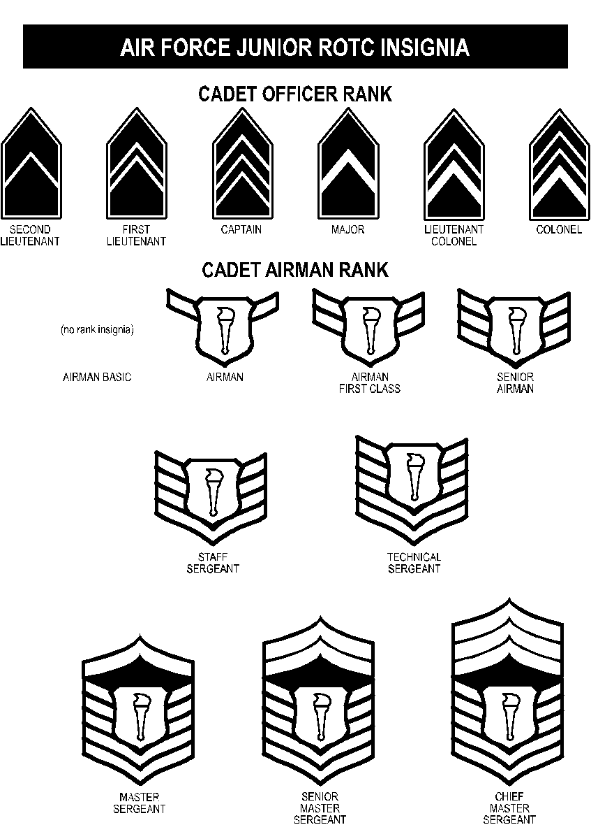

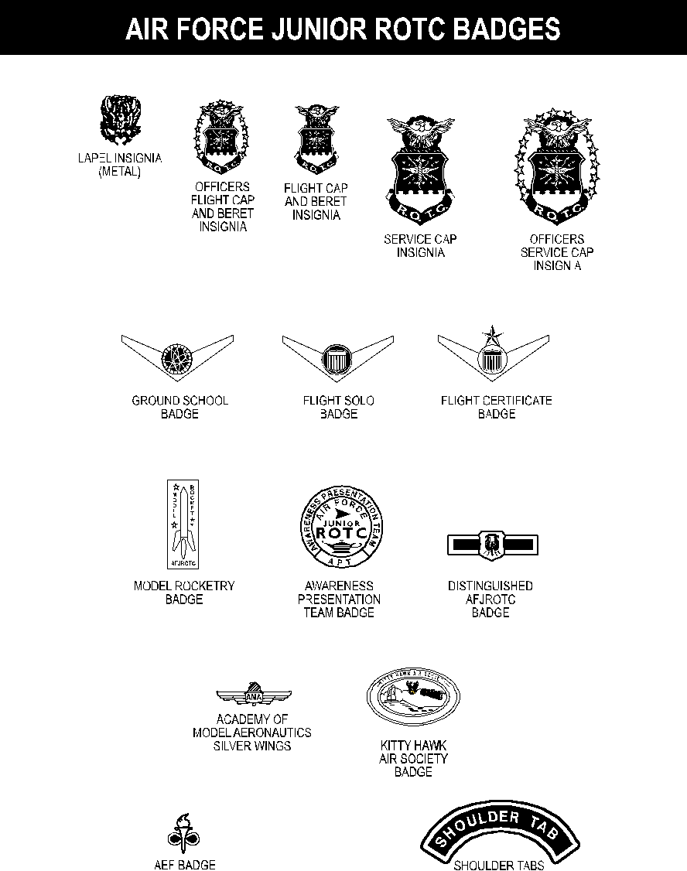

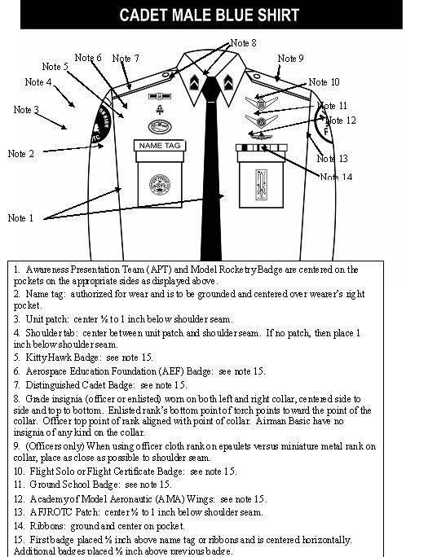

Note 12

Note 12

Note 10

Note 11

Note 11

Note 10

Note 13

Note 14

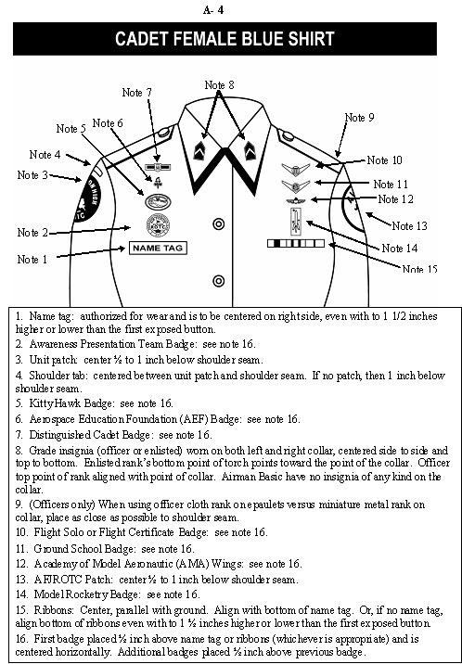

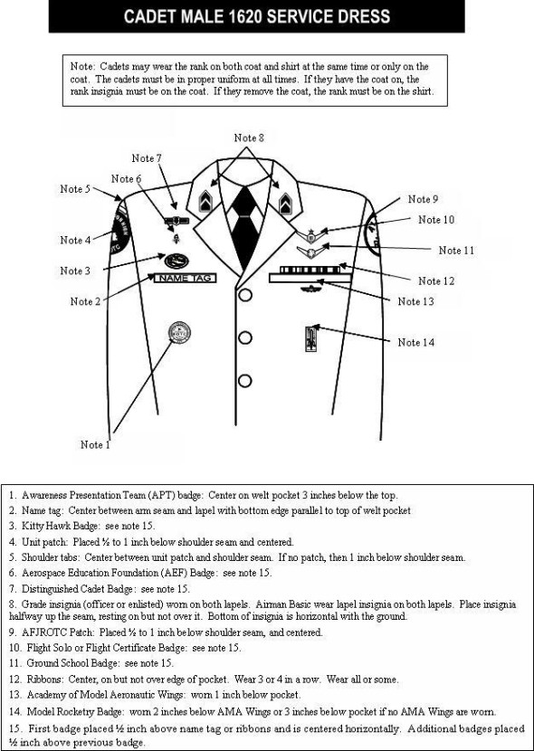

1. Awareness Presentation Team (APT) badge: Center on welt pocket 3 inches below the top.

2. Name tag: Center between arm seam and lapel with bottom edge parallel to top of welt pocket

3. Kitty Hawk Badge: see note 15.

4. Unit patch: Placed ½ to 1 inch below shoulder seam and centered.

5. Shoulder tabs: Center between unit patch and shoulder seam. If no patch, then 1 inch below shoulder seam.

6. Aerospace Education Foundation (AEF) Badge: see note 15.

7. Distinguished Cadet Badge: see note 15.

8. Grade insignia (officer or enlisted) worn on both lapels. Airman Basic wear lapel insignia on both lapels. Place insignia halfway up the seam, resting on but not over it. Bottom of insignia is horizontal with the ground.

9. AFJROTC Patch: Placed ½ to 1 inch below shoulder seam, and centered.

10. Flight Solo or Flight Certificate Badge: see note 15.

11. Ground School Badge: see note 15.

12. Ribbons: Center, on but not over edge of pocket. Wear 3 or 4 in a row. Wear all or some.

13. Academy of Model Aeronautic Wings: worn 1 inch below pocket.

14. Model Rocketry Badge: worn 2 inches below AMA Wings or 3 inches below pocket if no AMA Wings are worn.

15. First badge placed ½ inch above name tag or ribbons and is centered horizontally. Additional badges placed ½ inch above previous badge.

1. Awareness Presentation Team (APT) badge: Center on welt pocket 3 inches below the top.

2. Name tag: Center between arm seam and lapel with bottom edge parallel to top of welt pocket

3. Kitty Hawk Badge: see note 15.

4. Unit patch: Placed ½ to 1 inch below shoulder seam and centered.

5. Shoulder tabs: Center between unit patch and shoulder seam. If no patch, then 1 inch below shoulder seam.

6. Aerospace Education Foundation (AEF) Badge: see note 15.

7. Distinguished Cadet Badge: see note 15.

8. Grade insignia (officer or enlisted) worn on both lapels. Airman Basic wear lapel insignia on both lapels. Place insignia halfway up the seam, resting on but not over it. Bottom of insignia is horizontal with the ground.

9. AFJROTC Patch: Placed ½ to 1 inch below shoulder seam, and centered.

10. Flight Solo or Flight Certificate Badge: see note 15.

11. Ground School Badge: see note 15.

12. Ribbons: Center, on but not over edge of pocket. Wear 3 or 4 in a row. Wear all or some.

13. Academy of Model Aeronautic Wings: worn 1 inch below pocket.

14. Model Rocketry Badge: worn 2 inches below AMA Wings or 3 inches below pocket if no AMA Wings are worn.

15. First badge placed ½ inch above name tag or ribbons and is centered horizontally. Additional badges placed ½ inch above previous badge.

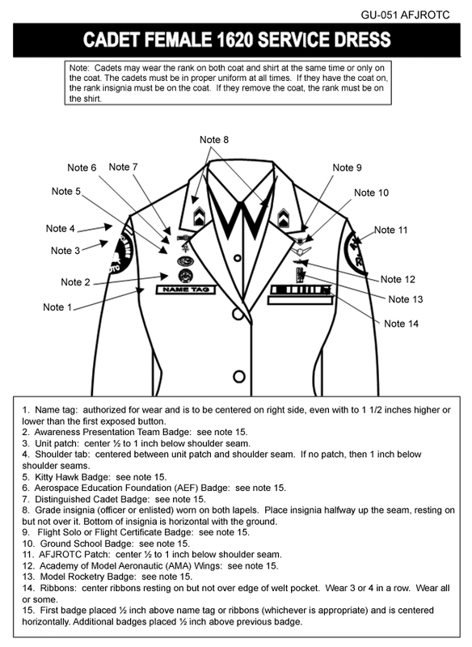

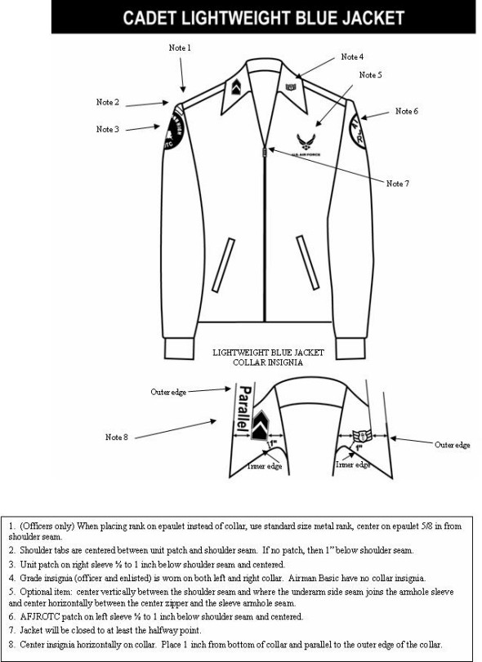

Note 12

Note 14

Note 13

Note 11

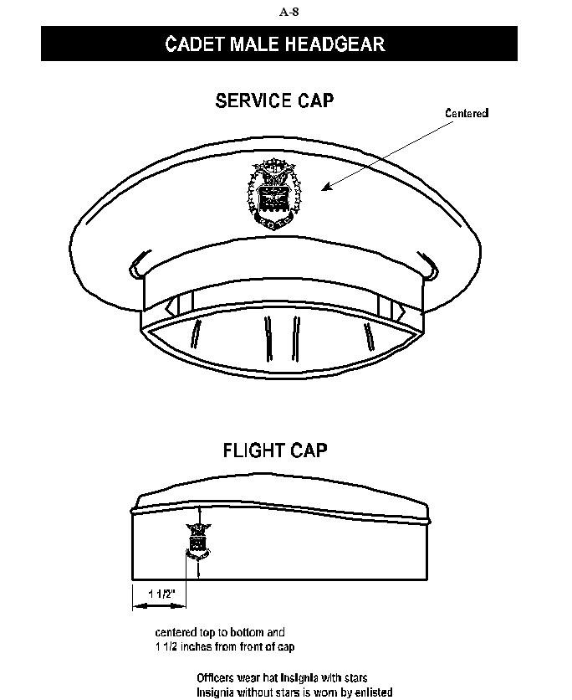

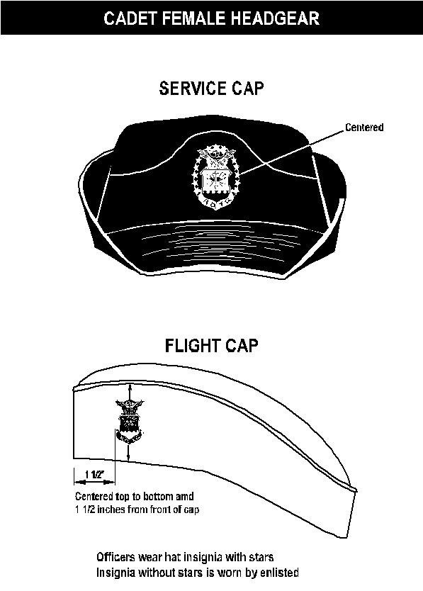

**A-9**

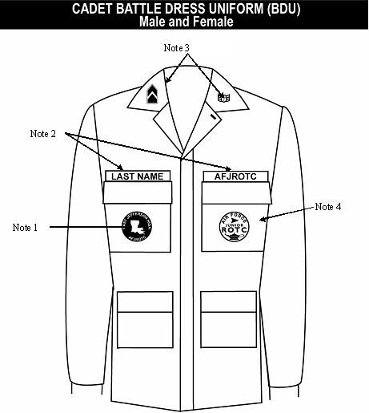

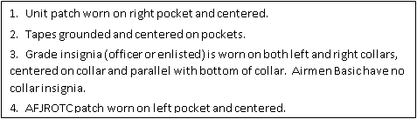

Outer edge

Windsor Knot (Right)

1. With the wide end 12

inches longer than the

narrow end

2. Make a loop as shown

3. Bring the wide end

around and behind the

narrow end

4. Turn the wide end up

and put it through the

loop of the tie

5. Pull the wide end

through and shape

carefully

Note: There are several good knot tutorials on YouTube.

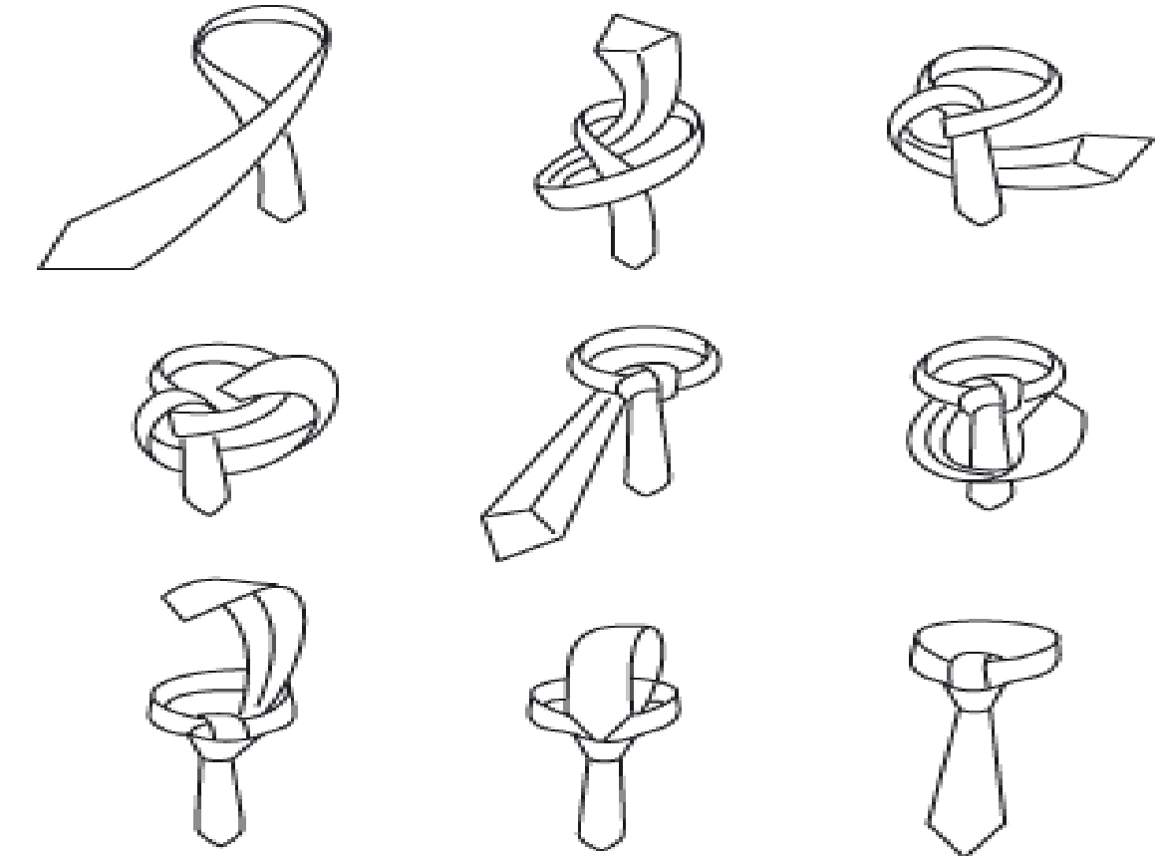

Four-In-Hand Knot

1. With the wide end of

the tie on the right side

2. Then cross the wide end over in back and to the left bring it

completely around the front to your right

3. Bring it back and up through the center

4. Pass it through the loop in front

5. Tighten the knot neatly, forming a "dimple" with your index finger.

Note: There are several good knot tutorials on YouTube.

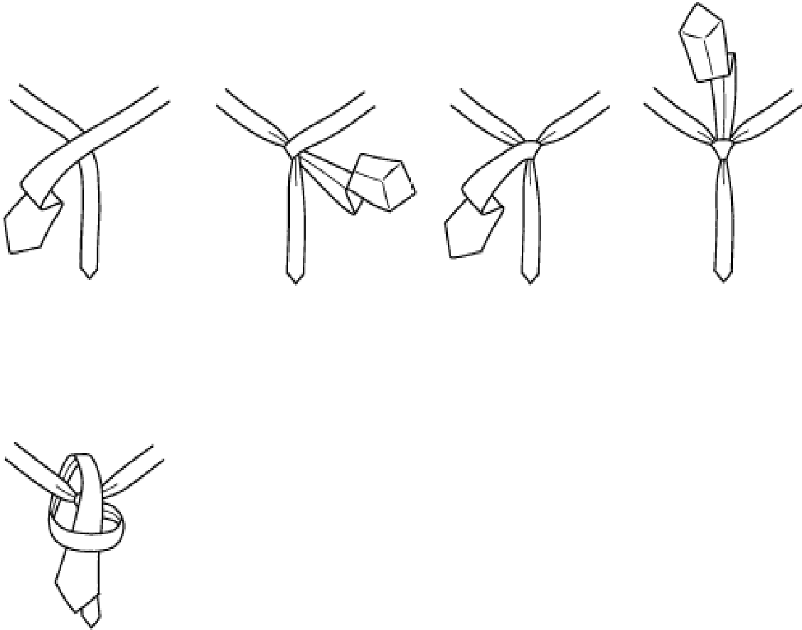

**NJ-20101**

**CORD & BERET GUIDE**

|  |  |  |
| --- | --- | --- |
| **Position Title**  **Corps Commander**  **KHAS**  **Drill Team**  **Color Guard**  **Raider Team Commander/Co** | **Shoulder Cord**  **Silver Cord with silver or nickel tip**  **Royal Blue**  **Green & Gold with nickel tip**  **White**  **Black** | **Beret**  **Yellow**  **Black** |

**AFROTC Sponsored Awards and AFJROTC Cadet Awards**

**HUMANITARIAN AWARDS**

|  |  |  |
| --- | --- | --- |
| AWARD  (Eligibility) | CADET REQUIREMENT | ELEMENT(S) |
| Valor  (All Cadets) | GOLD: Voluntary act of bravery and self-sacrifice involving conspicuous risk of life beyond call of duty. | Medal, Ribbon, Citation |
|  | SILVER: Voluntary act of heroism which does not involve risk of life. | Medal, Ribbon, Citation |
| Humanitarian  (All Cadets) | Humanitarian act above call of duty in response to a natural disaster or catastrophe | Ribbon, Certificate |
| Community Service  (All Cadets) | Significant leadership in the planning/execution of a major unit community service project. | Ribbon, Certificate |
|  |  |  |
| **NATIONAL LEVEL AFJROTC AWARDS** | | |
| Air Force Association  (AS III) | Excel in position of responsibility, exhibit strong attitude; exemplary personal appearance, personal attributes, and courtesy; and show growth potential. Top 5% of AS-III and top 10% of high school class. Recommended for Outstanding Cadet Ribbon by SASI. | Medal, Ribbon |
| Daedalian  (AS III) | Demonstrate patriotism, love of country, and service. Potential and desire to pursue a military career. Top 10% of AS III class and top 20% of high school class. | Ribbon |
| American Legion Scholastic  (AS III or IV) | Overall scholastic achievement. Top 10% of high school class and top 25% of AS-III or IV. Demonstrate leadership and participate in student activities. | Medal, Ribbon |
| American Legion General  Military Excellence Award  (AS III or IV) | General military excellence. Top 25% of AS-III or IV Outstanding leadership, discipline, character, and citizenship. | Medal, Ribbon |
| Daughters of the American  Revolution Award  (AS IV) | Top 25% AS IV and high school class. Be dependable with good character, disciplined, a strong leader, and committed to importance of AFJROTC training. | Medal, Ribbon |
| American Veterans  (AS-I, II, III, IV) | Possess positive attitude, outstanding personal appearance and character, and officer potential. Have “A” in AS-I and “C” in all classes at time of selection and presentation. | Medal, Ribbon |
| Reserve Officers Association (ROA)  (AS-IV) | Have a positive attitude, outstanding personal appearance, character, courtesy, growth potential, and strong ethics. Be in upper 10% of AS class. | Medal, Ribbon, Certificate |

**AFROTC Sponsored Awards and AFJROTC Cadet Awards (Cont.)**

|  |  |  |
| --- | --- | --- |
| AWARD (Eligibility) | CADET REQUIREMENT: | ELEMENTS |
| Military Order of World Wars  (AS-I, II, III, IV) | Excel in all academics and military training. Actively participate in Extracurricular activities. Want to serve country and to continue in AFJROTC. | Medal, Ribbon, Certificate |
| Military Officers Association of America (MOAA)  (AS-III/Junior) | Be a junior academically in good standing. Exhibit high morals and loyalty. Have exceptional military leadership potential. | Medal, Ribbon |
| Veterans of Foreign Wars  (AS-III or IV) | Show positive attitude towards AFJROTC. Have outstanding military bearing and conduct. Have strong positive character. Be patriotic with leadership potential. Have “B” in AFJROTC and “C” in all other classes. Be active in student activities. Not have received award previously | Medal, Ribbon |
| National Sojourners (AS-II or III) | Be in upper 25% of high school class. Encourage and demonstrate Americanism. Show leadership potential. Not have received award previously. | Ribbon, Certificate |
| Sons of the American Revolution  (AS-III) | Show high degree of leadership potential military bearing, and excellence in AFJROTC. Be in top 10% of AS class and upper 20% of high school class. | Medal, Ribbon |
| Scottish Rite, Southern Jurisdiction  (AS-III) | High degree of leadership, military bearing, and all around excellence. Top 25% of high school class. | Medal, Ribbon |
| Military Order of the Purple Heart  (AS-III or IV) | Show positive attitude towards country and AFJROTC. Outstanding performer in Corps leadership position. Be active in school and community. Have “B” in all subjects. Not have received award previously. | Medal, Ribbon |
| Air Force Sergeants Association  (AS-III or IV) | Be in top 25% of AS-III or IV. Show outstanding leadership, discipline, character, and citizenship. Not have received award previously. | Medal, Ribbon |
| Sons of Union Veterans of the  Civil War  (AS-I, II, III, IV) | Show patriotism demonstrated a high degree of academic excellence and leadership ability. | Medal, Ribbon |

**AFROTC Sponsored Awards and AFJROTC Cadet Awards (Cont.)**

|  |  |  |
| --- | --- | --- |
| AWARD  (Eligibility) | CADET REQUIREMENT: | ELEMENTS) |
| Tuskegee Airmen Incorporated  (AS-I, II, III)  2 cadets | Attain a grade of “B” or better in AFJROTC  Be in good academic standing. Actively participate in cadet corps activities. Participate in at least 50% of all service projects. | Ribbon, Certificate |
| Outstanding Cadet  (One Cadet each  AS-I, II, III, IV) | Show high morals and outstanding military potential. Demonstrate positive personal character. Attain academic and military excellence. | Ribbon  Full Year |
| Leadership  (5% of Cadets) | Be assigned and excel in leadership position.  Exhibit outstanding performance. | Ribbon  Semesterized |
| Achievement  (5% of Cadets) | Accomplish significant documented achievement (community/school services, ROTC Scholarship, Academy appointment, contest winner, Athletic achievement, Valedictorian/Salutatorian, etc.) “C” average in AFJROTC. Awarded once each school year. | Ribbon  Semesterized |
| Superior Performance  (10% of Cadets) | Render outstanding achievement or  meritorious service in behalf of AFJROTC for a  single or sustained act of a superior nature  (National Merit Finalists, yearbook editor, most valuable athlete, outstanding performer in community sanctioned activity) | Ribbon  Semesterized |
| Distinguished  Unit  (All Cadets) | Be enrolled in AFJROTC at Seneca High School during period of award and making satisfactory progress | Ribbon |
| Aerospace and Technology Honors Camp  (All Cadets) | Awarded for attendance at Honors Camp | Ribbon |
| Top Performer  (All Cadets) | The Cadet Top Performer Award is a Headquarters, AFJROTC award presented to a  maximum of 2% of the current unit cadet corps  population. | Ribbon |
| Academic  (All Cadets) | Achieve an “A” in AFJROTC during term  and an overall “B” GPA with no failures. | Ribbon  Semesterized |
| Outstanding Flight  (All Cadets) | Be assigned to the outstanding flight  during an academic semester. | Ribbon  Semesterized |
| Leadership School  (All Cadets) | Successfully complete Leadership School | Ribbon |

**AFROTC Sponsored Awards and AFJROTC Cadet Awards (Cont.)**

|  |  |  |
| --- | --- | --- |
| AWARD  (Eligibility) | CADET REQUIREMENT: | ELEMENTS) |
| Drill Competition  (All Cadets) | Place in Air Force or Joint drill meet. | Ribbon |
| Orienteering  Competition  (All Cadets) | Awarded to team members for placing first, second or third place in an orienteering meet. | Ribbon |
| Co-curricular  Activities  Leadership  (All Cadets) | Demonstrate exceptional leadership as project officer for AFJROTC Co-curricular activity (Dining-In, Cadet Ball, newsletter editor, Drill Team Commander, Color Guard Team Commander, orientation program coordinator etc. Note: May be earned up to four times. | Ribbon  Semesterized |
| Drill Team  (All Cadets) | Participate in at least 75% of all scheduled Drill Team practices and events in which selected to participate. | Ribbon  Full Year |
| Color Guard  (All Cadets) | Participate in at least 75% of all scheduled Color Guard practices or 10 formal events in which selected to participate. | Ribbon  Full Year |
| Saber Team  (All Cadets) | Awarded for distinguished participation in at least 75% of events. | Ribbon  Full Year |
| Service  (All Cadets) | Show distinctive performance in a minimum of three school, community, or AFJROTC service projects each school year. Includes AFJROTC fundraising (min of 10 hrs of service required) | Ribbon  Semesterized |
| Health & Wellness  (All Cadets) | Participate in a regular physical conditioning program. Devices may be earned for superior performance as specified in the H&W Program guidelines. | Ribbon  Semesterized |
| Recruiting  (All Cadets) | Awarded for outstanding effort in support of recruiting activities. Recruited at least two cadets | Ribbon  Semesterized |
| Activities  (All Cadets) | Participate in two formally scheduled co-curricular activities such as parades, academic meets, etc. to receive award each school year. Participate in four additional activities to receive additional clusters. | Ribbon  Semesterized |
| Attendance | Awarded to cadets with no unexcused absences. Max of four excused absences and no more than 1 tardy during the term | Ribbon  Semesterized |
| Good Conduct  (All Cadets) | No suspensions of any kind, no adverse reports from any faculty, no tardy reports in a semester. No skipped uniform inspections. | Ribbon  Semesterized |
| Dress and  Appearance  (25% of cadets) | Wear uniform on all designated uniform days and conform with all AFJROTC dress and appearance standards. Scored 92% or higher on all inspections. | Ribbon  Semesterized |
| Longevity  (All Cadets) | Successfully complete an Aerospace Science course with a “C” or better grade. | Ribbon  Full Year |

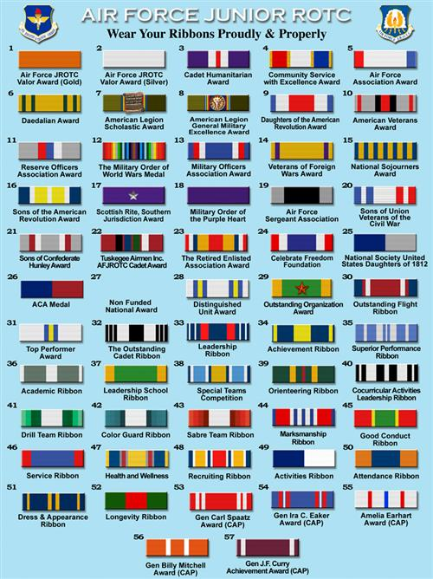

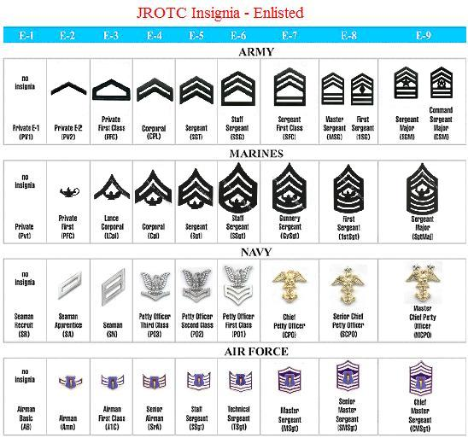

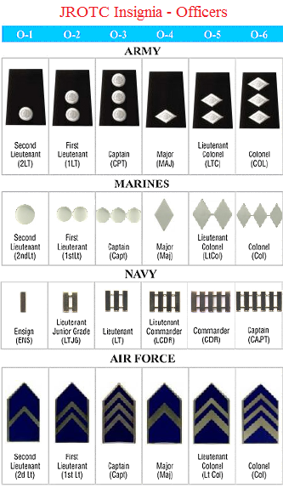

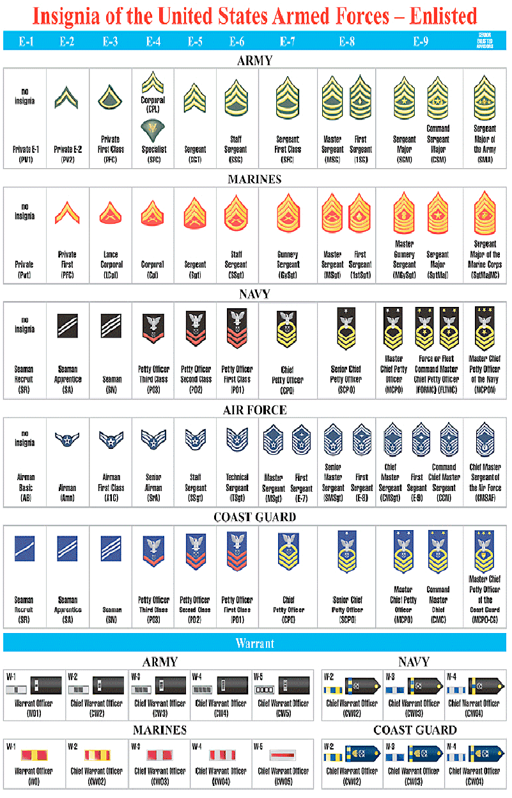

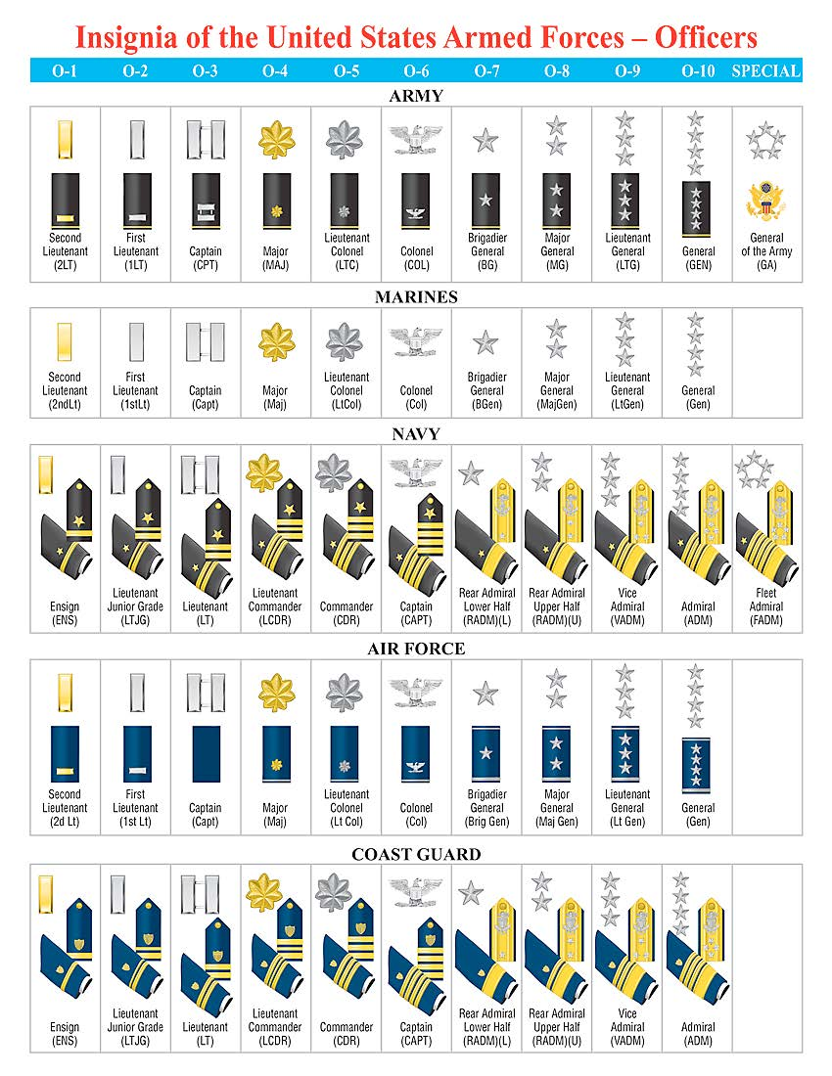

**Phonetic Alphabet**

**A - Alpha N - November**

**B - Bravo O - Oscar**

**C - Charlie P - Papa**

**D - Delta Q - Quebec**

**E - Echo R - Romeo**

**F - Foxtrot S - Sierra**

**G - Golf T - Tango**

**H - Hotel U - Uniform**

**I - India V - Victor**

**J - Juliet W - Whiskey**

**K - Kilo X - X-ray**

**L - Lima Y - Yankee**

**M - Mike Z – Zulu**

**Military Time**

Military time is based on a “24 hour clock”.

**1 am = 0100 hours 1 pm = 1300 hours**

**2 am = 0200 hours 2 pm = 1400 hours**

**3 am = 0300 hours 3 pm = 1500 hours**

**4 am = 0400 hours 4 pm = 1600 hours**

**5 am = 0500 hours 5 pm = 1700 hours**

**6 am = 0600 hours 6 pm = 1800 hours**

**7 am = 0700 hours 7 pm = 1900 hours**

**8 am = 0800 hours 8 pm = 2000 hours**

**9 am = 0900 hours 9 pm = 2100 hours**

**10 am = 1000 hours 10 pm = 2200 hours**

**11 am = 1100 hours 11 pm = 2300 hours**

**12 pm = 1200 hours 12 am = 2400 / 0000 hours**

Replacement Price List

Male

Item_____________________________________ Cost

Flight Cap, Male Shade 1620__________________ $10.00

Coat, Service Dress Male Blue 1620____________ $88.00

Jacket, Lightweight Male Blue 1605_____________ $93.00

Shirt, Male Light Blue Short Sleeve Shade 1550___ $13.00

Trousers, Male Blue Shade 1620_______________ $35.00

Belt/Blue__________________________________ $ 6.00

Necktie, Blue Male__________________________ $ 5.00

Female

Item_____________________________________ Cost

Flight Cap, Female Airman Shade 1620__________ $ 7.00

Slacks, Female, Blue Shade 1620_______________ $31.00

Coat, Female Service Dress Blue Shade 1620______ $82.00

Coat, Lightweight Female Blue 1605_____________ $93.00

Blouse, Female Light Blue Short Sleeve Shade 1550_ $13.00

Belt/Blue___________________________________ $ 6.00

Tab, Blue Female_____________________________ $ 4.00

Miscellaneous Uniform Items

Item_______________________________________ Cost

Ribbons____________________________________ $ 0.75

Ribbon Bars_________________________________ Price varies by size

Devices (Oak leaf clusters, stars, etc.)_____________ $ 0.25

Insignia, Flight Cap, Officer_____________________ $ 6.00

Insignia, Rank, Metal, Miniature, Officer __________ $ 7.95

Insignia, Rank, Metal, Large, Officer ______________ $12.50

Insignia, Rank, Metal, Airman ___________________ $10.00

Rank, Cloth, Officer ___________________________ $ 5.00

Name Tag, Blue Plastic_________________________ $ 2.00

Uniform Cord/Rope____________________________ $12.00

Note: All are unit prices unless otherwise noted and all prices are subject to change.

|  |  |  |  |  |  |  |  |  |  |  |  |  |  |
| --- | --- | --- | --- | --- | --- | --- | --- | --- | --- | --- | --- | --- | --- |
| **Uniform Inspection Sheet** | | | | | | | | | | **Date: ________________**  **Flight: _____________** | | | |
|  | **Last Name, First** | | **Uniform Cleanliness** | **Accouterments** | **Personal Grooming** | **Accessories** | **Military Bearing** | | **Total Score** | | **Comments** | |
| 1 |  | |  |  |  |  |  | |  | |  | |
| 2 |  | |  |  |  |  |  | |  | |  | |
| 3 |  | |  |  |  |  |  | |  | |  | |
| 4 |  | |  |  |  |  |  | |  | |  | |
| 5 |  | |  |  |  |  |  | |  | |  | |
| 6 |  | |  |  |  |  |  | |  | |  | |
| 7 |  | |  |  |  |  |  | |  | |  | |
| 8 |  | |  |  |  |  |  | |  | |  | |
| 9 |  | |  |  |  |  |  | |  | |  | |
| 10 |  | |  |  |  |  |  | |  | |  | |
| 11 |  | |  |  |  |  |  | |  | |  | |
| 12 |  | |  |  |  |  |  | |  | |  | |
| 13 |  | |  |  |  |  |  | |  | |  | |
| 14 |  | |  |  |  |  |  | |  | |  | |
| 15 |  | |  |  |  |  |  | |  | |  | |
| 16 |  | |  |  |  |  |  | |  | |  | |
| 17 |  | |  |  |  |  |  | |  | |  | |
| 18 |  | |  |  |  |  |  | |  | |  | |
| 19 |  | |  |  |  |  |  | |  | |  | |
| 20 |  | |  |  |  |  |  | |  | |  | |
| 21 |  | |  |  |  |  |  | |  | |  | |
| 22 |  | |  |  |  |  |  | |  | |  | |
| **Uniform Cleanliness:**  Shirt, Coat, Pants, Hat, Undershirt  *Deductions:* -5 points per item  *Max Deductions:* -25 points | | **Accouterments:**  Name tag, Ribbons, Rank, Insignia  *Deductions:* -4 points per item  *Max Deductions:* -20 points | | | | | | **Personal Grooming:**  Hair, Shave, Nails/Make-up, Jewelry  *Deductions:* -4 points per item  *Max Deductions:* -20 points | | | |
| **Inspector Name:**  _____________________  **Assistant:**  _____________________ | | **Accessories:**  Shoes, Socks, Tie/Tab, Belt, Gig  *Deductions:* -5 points per item  *Max Deductions:* -25 points  +5 points for highly polished shoes | | | | | | **Military Bearing:**  Pos. of Attention, personal bearing  *Deductions:* -5 points per item  *Max Deductions:* -10 points | | | |